Supplementary Information

A fucosyltransferase inhibition assay using image-analysis and digital microfluidics

Laura M. Y. Leclerc,^{1,2} Guy Soffer,^{2,3} David H. Kwan,^{1,2} Steve C.C. Shih*¹⁻³

¹Department of Biology, Concordia University, Montréal, Québec, Canada
²Centre for Applied Synthetic Biology, Concordia University, Montréal, Québec, Canada

³Department of Electrical and Computer Engineering, Concordia University, Montréal, Québec, Canada

*Corresponding author

Tel: +1-(514)-848-2424 x7579

Email: steve.shih@concordia.ca

Transformation of Abg2F6, BgaA, SpHex and FucT expression strains

After thawing on ice, BL21(DE3) stocks were incubated in separate 2 mL Eppendorf tubes into which pET29-Abg2F6, pET28-BgaA, pET3a-His6-SpHex, or pET21-FucT was added. A negative control tube containing cells were inoculated by the plasmid without the gene insert (e.g., pET28). Before transformation, cells were kept on ice for 5 min, then heat shocked at 42 °C for 45 s and returned to ice for 2 min. 1 mL of SOC media was added to each tube, after which cells were heat shocked at 42 °C for 45 s and returned to ice for 2 min again. After 1 h of incubation at 37 °C, the tubes were centrifuged at 14,000 g for 1 min. 100-200 μL of the transformed cells were plated on the LB-agar plates prepared with the appropriate antibiotic selection marker. Plates were left in the incubator at 37 °C overnight and colonies were counted after 24 h.

Protein expression and purification for Abg-2F6, BgaA, SpHex and FucT

Colonies of E. coli BL21(DE3) transformed with pET29-Abg2F6, pET28-BgaA, pET3a-His6-SpHex or pET21-FucT were picked from their plates and used to inoculate 4 mL volumes of LB containing 100 μg/mL of their respective antibiotics. Each starter culture was grown overnight at 37 °C with shaking at 220 rpm. 400 mL LB was then inoculated with 4 mL of starter culture and grown in the same conditions for 2-5 h at 37 °C until OD₆₀₀ reached ~0.6, at which point protein expression was induced with 0.1 mM IPTG. BgaA and FucT were expressed overnight at 30 °C and SpHex at 25 °C, all with shaking at 220 rpm.
Cells were harvested by centrifugation (10,000 g, 4 °C, 15 min), then resuspended in lysis/wash buffer (For BgaA and SpHex: 50 mM Tris; 500 mM NaCl; 7.5 mM imidazole; pH 8. For Abg2F6: 20 mM Tris; 500 mM NaCl; 5 mM imidazole; pH 8. For FucT: 35 mM Tris; 500 mM NaCl; 7.5 mM imidazole; pH 8.) Cell suspensions were frozen at -20 °C before purification could resume.
After thawing on ice, lysozyme, DNAse I, and RNAse A were each added to 5 μg/mL. For each protein, one half of a Roche protease inhibitor tablet (Sigma-Aldrich, Inc.) was dissolved in 500 μL deionized water and then added. Cells were lysed by sonication (amplitude 25 %; pulse on 5 s, off 15 s; total time 3 min) then centrifuged at 4 °C with 15,000g or 30 min. 0.22 μm syringe filters were used to filter each supernatant.
After using 10 mL lysis/wash buffer to equilibrate the 1 mL Thermo Scientific™ HisPur™ Ni-NTA Resin cartridges, filtered protein lysates were added to the cartridges and the lysate flow-through collected for later analysis with SDS-PAGE. 10 mL lysis/wash buffer were added and the wash flow-through was collected.
FPLC was performed with an Äkta FPLC System and an increasing imidazole gradient (0 mM to 400 or 800 mM) over 30 mL, collecting 1 mL fractions. This was achieved by gradually increasing the ratio of elution buffer to lysis/wash buffer being pumped into the cartridge. The elution buffers used for BgaA, SpHex and FucT were identical to their lysis/wash buffers with the addition of 400 mM imidazole (BgaA and Abg2F6) or 800 mM imidazole (SpHex and FucT). Lysis/wash and elution buffers were degassed before use and fractions were stored at 4 °C.
After collecting fractions of interest identified by peaks in UV absorbance at 280 nm, SDS-PAGE was performed to identify those which contained the protein of choice. Each selected fraction was visually assessed to be ≥ 95 % pure. Selected fractions for the same protein were pooled together. Pooled samples were concentrated by centrifugation with Vivaspin® 20 concentrators to <0.5 mL by spinning at 4200g for 16-43 minutes at 4 °C. 10DG Desalting columns (Bio-Rad) were equilibrated with 20 mL storage buffer (20 mM Tris, 150 mM NaCl, pH 7.5 for Abg2F6, BgaA, SpHex, and 25 mM Tris, 150 mM NaCl, pH 7 for FucT). Concentrated protein samples were buffer exchanged with storage buffer using the equilibrated 10DG Desalting columns according to the manufacturer specifications and stored at 4 °C and -20 °C. Protein concentrations were quantified by BCA assay using the Pierce™ BCA Protein Assay Kit (Thermo Scientific™).

Enzymatic synthesis and purification of MU-β-LacNAc

Mutant glycosynthase Abg2F6 was used in vitro to chemoenzymatically synthesize MU-β-LacNAc from 4-methylumbelliferyl N-acetyl-β-D-glucosaminide (MU-β-GlcNAc) and αGalF.[2] Briefly, synthesis was performed at room temperature with a solution containing 2.7% DMSO, 0.1 mM MU-β-GlcNAc, 4 mM αGalF, and 0.5 mg/mL Abg-2F6 in 50 mM pH 7.15 potassium phosphate. Potassium phosphate buffer was prepared to pH 7.15. The reaction was set on a rotating rube rack for 48 h, after which Thin Layer Chromatography (TLC) was performed to assess the presence of new product as shown in supplementary information. (Fig. S3a) TLC spots were identified by comparing them to those reported previously, for which NMR characterization had been previously performed [4].
Column purification was performed with a C18 Hypersep™ hydrophobic, reverse phase column (Thermo Scientific™), washed with methanol prior to equilibration with dH₂O. The MU-β-LacNAc reaction mix was added, after which three fractions were eluted with just dH₂O, then 11 fractions were eluted with increasing concentrations of MeOH by 5% increments. Rotary evaporation was performed with a 40 °C water bath was used to gently evaporate MeOH and H₂O from the sample. Liquid-liquid extraction with a few mL of ethyl acetate was used to further purify the sample residual 4-MU was separated into the organic ethyl acetate layer while MU-β-LacNAc was retained in the aqueous layer. TLC verified that high purity was achieved after four extractions. MU-β-LacNAc was freeze-dried to obtain ~5.0 mg product.

DMF device fabrication

Photolithography was used to fabricate DMF chips in a cleanroom. The 2” x 3” DMF design was prepared in AutoCAD. A high-resolution transparency (25400 dpi) was printed by CAD/Art Services Inc. (Bandon, OR), with a minimum guaranteed feature size of 10 μm. 2” x 3” glass slides evaporated with chrome oxide and coated with AZ-100 photoresist were ordered from Telic (Valencia, CA) and these were exposed with the mask for 5 s to UV light. The solubilized photoresist was removed with MF-321 developer acquired from Rohm and Haas Company (Marlborough, MA). Cr etching was performed with CR-4 chromium etchant from OM Group Inc. (Cleveland, OH) and the remaining photoresist was removed using AZ-300T from AZ Electronic Materials plc (Somerville, NJ).
After photolithography, DMF devices were primed for 15 min with 50:50:1 deionized water : isopropanol : silane solution. Contact pads on the DMF devices were then covered with heat-resistant tape. The SCS Labcoter 2 PDS 2010 from Specialty Coating Systems Inc. (Indianapolis, IN) was used for the chemical vapor deposition of 5 μm of parylene-C.
Top-plates ITOs (indium tin oxide) were acquired from Delta Technologies Limited (CG-611N-S207; Loveland CO). 1% Teflon-AF 1600 was prepared by dissolving dry pellets in FC-40 from Sigma-Aldrich at 65 ℃ for five days followed by 0.22 mm syringe filter sterilization. A WS-650 Spin Coater from Laurell Technologies Corporation (North Wales, PA) was used to apply a thin layer of 1 % Teflon AF 1600 hydrophobic coating to both the device and the top-plate ITOs. For device assembly, two layers of double-sided tape were used to adhere the ITO to the DMF chip.

Description on constructing electrode sequences using PaseMaker

Writing dozens of actuation sequences with a hundred numbered electrodes on a DMF device can be costly with regards to time and human error. A program called Pasemaker.py was created to automate construction of electrode sequences universally (for any and all DMF designs), with thought to compatibility with other softwares and future functionality.
When PaseMaker is used alone, users provide a .csv file listing each electrode of a DMF device as its reference pin number on a separate row, and for each electrode, the electrodes adjacent to it are listed in any number of columns on that same row. From this information, Pasemaker constructs non-visual graphs which map out the DMF chips as networks in which every electrode is a node and every connection between electrodes is of a certain distance (the distance is automatically assigned as 1). Pasemaker’s windowed interface allows users to load their .csv from a file browser/picker, after which it allows them to view, select and copy to the clipboard the raw numeric graph produced by Pasemaker. In a text input box on the interface, the user could choose to provide a customizable string in which they could specify where the sequence would be inserted once it had been created. In two other provided spaces, the user could enter the pin number of the start and end point electrodes, after which they could select what kind of sequence they wished to construct between those for Moving, Dispensing, Low-Volume Dispensing, Mixing in a line, Mixing in a circle, or Splitting of volumes between the two user-specified electrodes. (Table S1) Pasemaker would then use Dijkstra’s Algorithm to solve for the shortest path and format it into the aforementioned customizable string, if it was provided. (Table S2)
Table S1) How PaseMaker constructs sequences
Sequence type and droplet activity | User-designated electrodes (Visual) | PaseMaker
Move (Moves from A to B) | 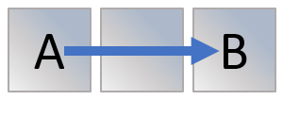 | Solves shortest path from A to B and constructs the electrode sequence from A to B
Dispense (Dispenses from A to B) | 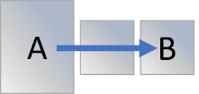 | Solves shortest path from A to B and constructs the electrode sequence from A to B, then appends the simultaneous actuation of A and B
Disp-LV (Useful to dispense from A to B even when volume in A is low) |  | Solves shortest path from A to B and constructs the electrode sequence from A to B, then, while keeping electrode B actuated at every step, appends the actuation of electrodes in reverse order (from B to A), ending with the simultaneous actuation of A and B
Mix-I (Mixing in a straight line A⇄B) | 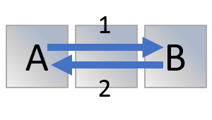 | Solves shortest path from A to B and constructs the electrode sequence from A to B, then appends the same sequence but with reversed order.
Split (Splits a central volume to A and B) | 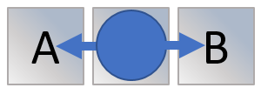 | Solves shortest path from A to B. Checks the number of electrodes: if odd, there is a single central electrode. If even, there are two central electrodes. Constructs the electrode sequence to actuate the central electrode(s) then simultaneously actuate a path from the central electrode(s) to A and to B.
Mix-O (Mixing in a circle encompassing A and B) | 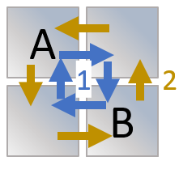 | Computes whether or not A and B are mutually connected to two other, separate electrodes. If so, then the path from A to B across one of these mutual adjacents is appended to the path from B to A across the other of the mutual adjacents. The sequence is constructed, then appended to itself but with reversed order.

Table S2) Examples of sequences made with PaseMaker
Example  DMF  Chip  design  Sequence  desired | 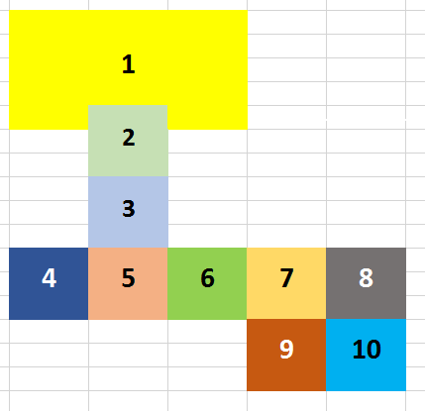
Move 1 to 5 | ⦗⦗1], ⦗1, 2], ⦗2], ⦗2, 3], ⦗3], ⦗3, 5], ⦗5]]
Dispense 1 to 5 | ⦗⦗1], ⦗1, 2], ⦗2], ⦗2, 3], ⦗3], ⦗3, 5], ⦗5], ⦗1, 5], ⦗1, 5]]
Disp-LV 1 to 5 | ⦗⦗1], ⦗1, 2], ⦗2], ⦗2, 3], ⦗3], ⦗3, 5], ⦗5], ⦗5, 2, 3], ⦗1, 2, 5]]
Mix-I 4 to 6 | ⦗⦗4], ⦗4, 5], ⦗5], ⦗5, 6], ⦗6], ⦗6], ⦗5, 6], ⦗5], ⦗4, 5], ⦗4]]
Split 4 to 6 | ⦗⦗5], ⦗4, 5, 6], ⦗4, 6]]
Split 4 to 7 | ⦗⦗5, 6], ⦗4, 5, 6, 7], ⦗4, 7]]
Mix-O 7 to 10 | ⦗⦗7], ⦗7, 8], ⦗8], ⦗8, 10], ⦗10], ⦗10, 9], ⦗9], ⦗9, 7], ⦗7], ⦗9, 7], ⦗9], ⦗10, 9], ⦗10], ⦗8, 10], ⦗8], ⦗7, 8], ⦗7]]

‘Bussing’ is the term given to a situation where multiple separate electrodes are controlled by the same switch, and as such, always actuate at the same time. Some DMF designs employ this to save space or to have more electrodes than the number of available control switches. To be fool-proof, Pasemaker automatically detects electrode bussing and assigns them different IDs in the graph so as to distinguish between spatially separate electrodes throughout its path-solving and sequence construction operations even if they shared the same pin number. If either or both of the electrodes specified for path solving were bussed, a window would pop up asking the user to select which of the displayed bussed electrodes to use for path solving and sequence making.
An automation system called ArduBridge was developed by Guy Soffer, which runs on the cross-platform coding language, Python 2.7. ArduBridge was run by inputting commands through the Python shell (IDLE). This would require entering a string of code into the python shell every time one wishes to actuate an electrode sequence during an experiment. To prevent slowing down device operation by repeatedly typing, and having to remember all of the sequence names, I created a GUI ( LLGUI) to be used as an interface for ArduBridge, with help from Guy Soffer. To make LLGUI possible, ArduBridge’s protocol file was also modified to include sequence categories and descriptions.
Typically, LLGUI read the user’s ArduBridge protocol file and created a window with a button for each droplet operation sequence. (Figure 14) These sequence buttons were grouped under their similar droplet operation categories (dispensing, movement, mixing, and stashing or unstashing from reservoirs) to facilitate organization and visual interpretation. A text input box allowed the user to specify the number of repeats required for the sequence. Hovering over a button displayed the tooltip (sequence description) and clicking the button copied the command string to one’s clipboard (this was achieved by using the python module, ‘pyperclip’). This could then be pasted in the shell, from which one could begin sequence actuation. LLGUI also included a button which would copy the ArduBridge command for closing the Arduino.

Figure S1 - Automation system diagram. Diagram of DMF setup labeled with 1. Power Supply, 2. Amplifier, 3. Function Generator, 4. Control Boards, 5. Arduino, 6. Contact Apparatus, 7. DMF chip, 8. Camera, 9. Laptop
Figure S2 – Automation GUI. Screenshots of the automation LLGUI.exe loaded with the protocol file for the DMF device used in this work.

Figure S3 – Screenshot of desktop appearance during an experiment. Screenshot with python-based GUI, python shell, and uEye camera software shown.

Figure S4 Fucosyltransferase inhibition assay protocol on a digital microfluidics device. Depiction of the steps involved in the assay. Step 1-5: Serial dilution spanning up to four orders of magnitude within five dilutions. Step 6: Addition of fucosyltransferase to inhibitor followed by 5+ minutes of incubation allowing the inhibitor to bind. Step 7: Addition of MU-β-LacNAc to the solution, which results in its fucosylation depending on the degree of inhibition attained in the previous step. Step 8: Introduction of a reaction stopping mix which consists of EDTA, SpHex and BgaA; EDTA to prevent further fucosyltransferase activity, and the glycoside hydrolases to sequentially cleave unfucosylated MU-β-LacNAc into its monosaccharide components.

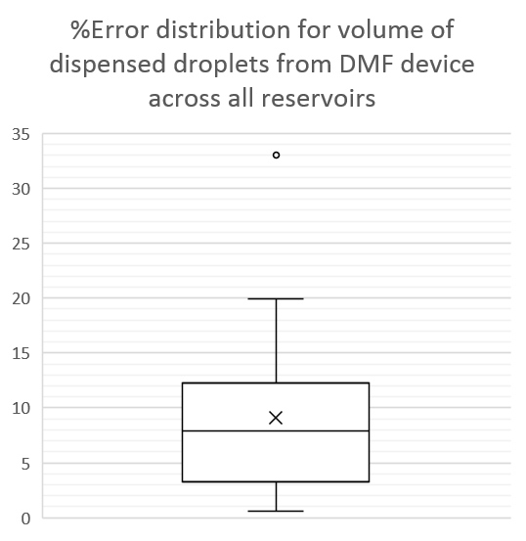
Figure S5 – Box-and-whisker plot of the % error of volumes dispensed on a DMF device. % Error was calculated by taking the difference in volume between a measured volume (calculated by pixel count) and the average of all volumes (N = 35).

Figure S6 – A proof-of-concept inhibition curve of FucT by GDP. Sigmoid curves and corresponding IC₅₀ were drawn and fitted to the formula y=b+((a-b)/(1+(x/c)^{d})) using a least squares routine by GNUPLOT-powered software available online at: (http://www.ic50.tk). Solutions were buffered in 50 mM Tris. Error bars represent one standard deviation.

Figure S7 – Electrode shapes. View of shapes prepared in AutoCAD with a 1 mm scale for comparison. The first row shows four skewed-wave electrodes, the second row shows 7 square electrodes of equal area to skewed-wave electrodes, and the third row shows 12 square electrodes of equal height to the skewed-wave electrodes. All electrodes have 30 µm gaps between them.

Figure S8 – Testing the effect of 0.05 % Tetronics data with and without oil on 4-MU fluorescence. Standards prepared in a well plate with different concentrations of Tetronics 150R1 at a concentration of 0.05% with or without 5% silicone oil.
Figure S9 - Accuracy and Precision of Pixel Count as a method of volume measurement. Error bars represent standard error. Different small volumes (0.5, 1, 1.5 and 2 µL represented on the x axis) were pipetted onto a DMF device mounted on a precision balance and the associated change in weight was recorded for each droplet. The average weight for each pipetted volume is represented on the y axis. (n=6) Using the same micropipette, the range of small volumes was also pipetted onto a DMF device and immediately covered with the ITO to prevent evaporation. A camera snapshot was taken, and using image analysis by pixel count and the formula (v = d_{pixels}*h_{gap}*a ÷ a_{pixels}) where v = volume in mm³ (or µL), d_{pixels} = pixels within the droplet area, h_{gap} = height of gap between device and ITO in mm, a = area in mm² of a known element of the device on the device; in this case, a reservoir was used; and a_{pixels} = area of the same element but measured in pixels in the same snapshot. Average volumes so obtained were plotted on the y axis.

Figure S10 – Calibration curves of the 4-MU standard with and without glycine. Standard linear regressions of 4-MU fluorescence of a DMF device before and after a 5-fold dilution in pH 10.4 1M glycine. All standards were prepared with 0.05% Pluronics and droplets coated with a silicone oil shell. Error bars represent one standard deviation.

REFERENCES

1. Kim, Y.W., et al., Directed evolution of a glycosynthase from Agrobacterium sp. increases its catalytic activity dramatically and expands its substrate repertoire. J Biol Chem, 2004. 279(41): p. 42787-93.
2. Kwan, D.H., et al., Chemoenzymatic Synthesis of a Type 2 Blood Group A Tetrasaccharide and Development of High-throughput Assays Enables a Platform for Screening Blood Group Antigen-cleaving Enzymes. Glycobiology, 2015. 25(8): p. 806-11.
3. Cold Spring Harbor Protocols. Preparation of 0.1 M Potassium Phosphate Buffer at 25°C. 2006 2016-11-07]; Available from: http://cshprotocols.cshlp.org/content/2006/1/pdb.tab19.
4. Kajihara, Y., et al., Synthesis of 2-[(2-pyridyl)amino]ethyl beta-D-lactosaminide and evaluation of its acceptor ability for sialyltransferase: a comparison with 4-methylumbelliferyl and dansyl beta-D-lactosaminide. Carbohydr Res, 2004. 339(8): p. 1545-50.

