Supporting Information

Droplet digital microfluidic system for screening filamentous fungi based on enzymatic activity

Kenza Samlali,^{1, 2} Chiara Leal Alves,^{1, 2} Mara Jezernik,³ Steve C.C. Shih ^{1,2,4}*
¹ Department of Electrical and Computer Engineering, Concordia University, Montréal, Québec, Canada
² Centre for Applied Synthetic Biology, Concordia University, Montréal, Québec, Canada

³ Department of Chemical Engineering and Applied Chemistry, University of Toronto, Toronto, Ontario, Canada

⁴ Department of Biology, Concordia University, Montréal, Québec, Canada

*Corresponding author

Tel: +1-(514) 848-2424 x7579

Email: steve.shih@concordia.ca

Supporting Information and Notes

Note 1: Device and automation system
In Figure 1, the channel-part of the microfluidic device was fabricated using PDMS with a height of 70 µm. For the electrode layer, the electrode gap is 15 µm, and a dielectric (SU-8 5) of 7 µm (smaller than half the size of the gap) was deposited on top. All other dimensions and architecture can be found in Supplementary Figure 1.
To apply potentials for sorting droplets, an AC potential was generated using a function generator (33201A Agilent, Allied Electronics, Ottawa, ON) and an amplifier (PZD-700A, Trek Inc., Lockport, NY) and sent to a custom board with Arduino UNO controlled optocoupler switches. For a detailed hardware overview, we refer to our previous work. Pump (Nemesys CETONI) and electrode operation were driven using python based software as described in our previous work.¹ In addition, background subtraction, gating and sorting were all performed through our Python based open-source software with GUI (GNU GPLv3, https://bitbucket.org/shihmicrolab/fungalmicrofluidics.git) (Supplementary Figure 13). Seabreeze was used as a Python library for communication with the spectrometer, allowing for compatibility of this software with several other affordable spectrometers (https://python-seabreeze.readthedocs.io). The graphical user interface consisted out of two main windows: one window contained the control interface, and another window contained a plot viewer with a raw spectrum and a processed spectrum (denoised and indicating the sorting gate) (Supplementary Figure 14).

Note 2: Spectrum detection and signal processing
To eliminate the background signal, we initially placed a band-pass filter in-line between the spectrometer and the outgoing 200 µm emission optical fiber. For peak detection, a program was created for detecting peaks that have a peak height above a user-defined threshold intensity. Although background noise was removed, the bandpass filter reduced the intensity of the peaks and useful information outside the band-pass filter range was lost. For example, air droplets reflected excitation light and showed peaks with a large base (> 200 nm) and high intensity often overlapping with the sample bandpass range. Air droplets were accidentally misidentified as droplets within the sorting gate. We finally opted to not use an emission bandpass filter and use a background subtraction method and peak detection algorithm instead. A background frame of experimental light conditions (excitation light, background light, noise, with oil sample) were recorded and subtracted from future frames (Supplementary Figure 3). The peak detection algorithm detects peaks (local maxima) in a subset (gate) of the spectrum. By setting the peak height range, peak base width, a wavelength and maximum peak height gate, and distance to neighboring peak, reliable detection of emission spectra could be performed. The resulting spectrum provided useful information on the sample type. As such, this peak detection method offers several advantages over specific wavelength based raw intensity detection performed with PMT’s.

Table 1. COMSOL electric field model parameters

Property | Value | Unit
PDMS relative permittivity | 2.75
PDMS electrical conductivity | 4x10⁻¹³ | S/m
HFE 7500 oil relative permittivity | 5.8
HFE 7500 electrical conductivity | 3x10⁻⁸ | S/m
Dielectric thickness SU-8 5 | 7.0 | µm
SU8-5 relative Permittivity | 4
SU8 electrical conductivity | 2.8x10⁻¹⁴ | S/m

Table 2. Comparison of system needs between typical FADS sorting setup and our system.

 | Equipment
Purpose | Typical FADS sorting setup | Samlali et al. sorting setup
Excitation | Laser, microscope, objectives for focusing | High power LED, optical fiber, in-line short pass filter
Detection | PMT | Optical fiber, mini-spectrometer
High-voltage electronics | Amplifier, function generator, high-volage and frequency switch board | None – only require low-voltage electronics (< 36 V)
Sorting efficiency | >90% | ~86%
Estimated costs | >$10k | $5k (most expensive is the spectrometer)
Droplet size | Picoliter range | Picoliter and nanoliter range
Throughput | Up to 20kHz | 7-20Hz
Droplet morphology | Uniform | Polydisperse

Table 3. Comparison of other fungi screening devices and our system.

 | Sorting parameters
Purpose | He, et al. 2019 | Beneyton, et al. 2016 | Samlali et al.
Screening marker | Cellulases (T. reesei) | α-Amylase (A. niger) | Chitinase and N- Acetylgalactosaminidase (Cl. Rosea)
Throughput | ~ 3 Hz (10,000 droplets/h) | 10 Hz | ~ 7 Hz (25,000 droplets/h)
Sorting mechanism | DEP | DEP | Electrostatic-based sorting
Incubation time | 12 hpi | 24hpi | 96hpi
Droplet size | ~ 1 nL (100 µm diameter) | 18 nL | Polydisperse (~ 0.5 – 1.5 nL)
Fold improvement | ~1.5 fold | ~2.3 fold | ~4 fold

Table 4. Slope of tip exiting overtime expressed in % hpi⁻¹.

Media composition | Slope | Std Error
1% G + MM | 1.04 | 0.1254
1% CC + 1% G + MM | 0.8952 | 0.1697
MM | 0.1079 | 0.06106
1% CC + 0.1% G + MM | 0.05128 | 0.01451

Table 5. One-way ANOVA (Dunnett's multiple comparisons test) of Rate of tip exiting [% hpi⁻¹]. P values: 0.1234 (ns), 0.0332 (*), 0.0021 (**), 0.0002 (***), <0.0001 (****).

Comparison | Significance | P Adj
GMM vs. CCMM + 1% G | **** | <0.0001
GMM vs. MM | **** | <0.0001
GMM vs. CCMM + 0.1% G | **** | <0.0001
CCMM + 1% G vs. MM | **** | <0.0001
CCMM + 1% G vs. CCMM + 0.1% G | **** | <0.0001
MM vs. CCMM + 0.1% G | ns | 0.2267

Table 6. Confusion matrix evaluation measures
Measure |  | Value
Error rate | ERR | 0.03703704
Accuracy | ACC | 0.96296296
Sensitivity | SN | 0.77142857
True positive rate | TPR
Recall | REC
Specificity | SP | 0.99519231
True negative rate | TNR
Precision | PREC | 0.96428571
Positive predictive value | PPV
False positive rate | FPR | 0.00480769
Matthews Correlation coefficient | MCC | 127.202795
F-score | F | 5
 | Beta | 0.5

Table 7. One-way ANOVA test of enzymatic activity of N-acetyl galactosaminidase overtime produced by recovered strains grown in GMM compared to the wild type. P values: 0.1234 (ns), 0.0332 (*), 0.0021 (**), 0.0002 (***), <0.0001 (****).

Strain | 0 days |  |  |  | 2 days |  |  |  | 4 days
 | Mean | StDev | Sig | P Adj | Mean | StDev | Sig | P Adj | Mean | StDev | Sig | P Adj
MC1 | 0.009739 | 0.005423 | ns | >0.9999 | 0.9105 | 1.02 | ns | 0.9993 | 1.409 | 0.9652 | ns | 0.9989
MC2 | 0 | 0 | ns | >0.9999 | 0.1546 | 0.0369 | ns | >0.9999 | 1.696 | 0.4029 | ns | 0.9945
MC3 | 0.007939 | 0.008399 | ns | >0.9999 | 0.01054 | 0.01023 | ns | >0.9999 | 0.3044 | 0.02672 | ns | >0.9999
MC4 | 0 | 0 | ns | >0.9999 | 0.0474 | 0.02469 | ns | >0.9999 | 0.6628 | 0.4233 | ns | 0.9996
MC5 | 0.06032 | 0.00555 | ns | 0.9998 | 0.5944 | 0.06037 | ns | 0.9996 | 0.9669 | 0.1497 | ns | 0.9994
MC6 | 0.7287 | 0.3971 | ns | 0.1251 | 1.304 | 0.72 | ns | 0.9955 | 2.535 | 0.9272 | ns | 0.8793
MC7 | 0.8145 | 0.5184 | ns | 0.0588 | 3.316 | 1.623 | ns | 0.3833 | 5.675 | 3.471 | * | 0.0329
MG1 | 0.4983 | 0.2795 | ns | 0.5827 | 4.232 | 2.633 | ns | 0.1228 | 2.984 | 2.049 | ns | 0.7045
MG2 | 0.6031 | 0.1601 | ns | 0.3186 | 4.559 | 0.6821 | ns | 0.0756 | 5.682 | 1.022 | * | 0.0326
MG3 | 0.07201 | 0.07644 | ns | 0.9997 | 1.682 | 0.3679 | ns | 0.9866 | 1.186 | 0.9199 | ns | 0.9991
MG4 | 0.2613 | 0.01513 | ns | 0.9943 | 11.83 | 2.146 | **** | <0.0001 | 13.03 | 2.606 | **** | <0.0001
MG5 | 2.141 | 1.657 | **** | <0.0001 | 9.828 | 9.46 | **** | <0.0001 | 11.85 | 9.73 | **** | <0.0001
MG6 | 0.3579 | 0.03329 | ns | 0.9287 | 5.368 | 1.159 | * | 0.0196 | 8.599 | 2.644 | *** | 0.0002
MG7 | 0.001594 | 0.002401 | ns | >0.9999 | 0.03187 | 0.01305 | ns | >0.9999 | 0.9459 | 0.5497 | ns | 0.9994
MG8 | 0 | 0 | ns | >0.9999 | 0.06389 | 0.04808 | ns | >0.9999 | 1.77 | 0.8474 | ns | 0.9941
MG9 | 0.001771 | 0.00262 | ns | >0.9999 | 0.1668 | 0.0669 | ns | >0.9999 | 0.6672 | 0.4389 | ns | 0.9996
MG10 | 0.000443 | 0.000886 | ns | >0.9999 | 0.2941 | 0.243 | ns | 0.9998 | 0.82 | 0.1891 | ns | 0.9995
MG11 | 0 | 0 | ns | >0.9999 | 0 | 0 | ns | >0.9999 | 0.1232 | 0.01103 | ns | >0.9999
MG12 | 0.004457 | 0.003382 | ns | >0.9999 | 0.4014 | 0.3191 | ns | 0.9997 | 1.792 | 1.455 | ns | 0.9897
MG13 | 0 | 0 | ns | >0.9999 | 0.02444 | 0.02913 | ns | >0.9999 | 0.3511 | 0.3706 | ns | 0.9999
wt | 0.01703 | 0.01807 |  |  | 0.0623 | 0.0457 |  |  | 0.1675 | 0.01074

Table 8. One-way ANOVA test of enzymatic activity of chitinase overtime produced by recovered strains grown in GMM compared to the wild type. P values: 0.1234 (ns), 0.0332 (*), 0.0021 (**), 0.0002 (***), <0.0001 (****).

Strain | 0 days |  |  |  | 2 days |  |  |  | 4 days
 | Mean | StDev | Sig | P Adj | Mean | StDev | Sig | P Adj | Mean | StDev | Sig | P Adj
MC1 | 0.001107 | 0.000995 | ns | >0.9999 | 1.874 | 2.003 | ns | 0.9386 | 2.284 | 1.533 | ns | 0.728
MC2 | 0 | 0 | ns | >0.9999 | 0.5933 | 0.08095 | ns | 0.9997 | 3.055 | 0.693 | ns | 0.2972
MC3 | 0.006257 | 0.000849 | ns | >0.9999 | 0.06747 | 0.004672 | ns | 0.9998 | 0.5119 | 0.03766 | ns | 0.9998
MC4 | 0.003586 | 0.004125 | ns | >0.9999 | 0.2745 | 0.0317 | ns | >0.9999 | 1.21 | 0.8243 | ns | 0.9989
MC5 | 0.1115 | 0.009706 | ns | 0.9996 | 1.824 | 0.07066 | ns | 0.9519 | 1.669 | 0.3144 | ns | 0.9766
MC6 | 1.21 | 0.6645 | * | 0.0157 | 3.148 | 1.685 | ns | 0.2903 | 3.334 | 2.503 | ns | 0.1933
MC7 | 1.18 | 0.2818 | * | 0.0201 | 6.971 | 2.595 | **** | <0.0001 | 7.411 | 3.481 | **** | <0.0001
MG1 | 0.8632 | 0.4955 | ns | 0.1888 | 7.861 | 3.582 | **** | <0.0001 | 6.964 | 2.391 | **** | <0.0001
MG2 | 1.059 | 0.1688 | ns | 0.0513 | 9.534 | 0.8587 | **** | <0.0001 | 8.173 | 1.057 | **** | <0.0001
MG3 | 0.1335 | 0.1347 | ns | 0.9996 | 3.546 | 0.6804 | ns | 0.1578 | 1.656 | 0.9794 | ns | 0.9785
MG4 | 0.3981 | 0.03502 | ns | 0.9762 | 13.17 | 0.6786 | **** | <0.0001 | 12.05 | 0.6693 | **** | <0.0001
MG5 | 2.957 | 2.118 | **** | <0.0001 | 9.253 | 6.149 | **** | <0.0001 | 9.671 | 5.08 | **** | <0.0001
MG6 | 0.6673 | 0.06918 | ns | 0.5098 | 10.31 | 1.35 | **** | <0.0001 | 10.71 | 1.46 | **** | <0.0001
MG7 | 0.000384 | 0.000483 | ns | >0.9999 | 0.195 | 0.04369 | ns | >0.9999 | 1.601 | 0.937 | ns | 0.9855
MG8 | 0 | 0 | ns | >0.9999 | 0.3435 | 0.01737 | ns | >0.9999 | 3.187 | 1.126 | ns | 0.2439
MG9 | 0.000561 | 0.000709 | ns | >0.9999 | 0.5857 | 0.1131 | ns | 0.9997 | 1.101 | 0.7507 | ns | 0.999
MG10 | 0 | 0 | ns | >0.9999 | 0.8523 | 0.6241 | ns | 0.9994 | 1.399 | 0.3528 | ns | 0.9944
MG11 | 0 | 0 | ns | >0.9999 | 0.004604 | 0.003726 | ns | 0.9997 | 0.1731 | 0.00843 | ns | 0.9999
MG12 | 0.01328 | 0.01009 | ns | >0.9999 | 1.076 | 0.8229 | ns | 0.9991 | 2.911 | 2.352 | ns | 0.3638
MG13 | 0 | 0 | ns | >0.9999 | 0.1554 | 0.1237 | ns | 0.9999 | 0.2531 | 0.03859 | ns | >0.9999
wt | 0.01434 | 0.01258 |  |  | 0.2729 | 0.04273 |  |  | 0.2885 | 0.03039

Table 9. One-way ANOVA test of enzymatic activity of glucanases overtime produced by recovered strains grown in GMM compared to the wild type. P values: 0.1234 (ns), 0.0332 (*), 0.0021 (**), 0.0002 (***), <0.0001 (****).

Strain | 0 days |  |  |  | 2 days |  |  |  | 4 days
 | Mean | StDev | Sig | P Adj | Mean | StDev | Sig | P Adj | Mean | StDev | Sig | P Adj
MC1 | 0.03112 | 0.02674 | ns | 0.9997 | 2.304 | 2.132 | ns | 0.9989 | 4.087 | 3.199 | ns | 0.9954
MC2 | 0.1132 | 0.07955 | ns | 0.9999 | 0.3242 | 0.2584 | ns | >0.9999 | 1.236 | 0.1666 | ns | 0.9998
MC3 | 2.043 | 3.701 | * | 0.0229 | 0.2705 | 0.13 | ns | 0.9999 | 0.7327 | 0.1643 | ns | 0.9996
MC4 | 0.1771 | 0.1875 | ns | >0.9999 | 0.4018 | 0.1115 | ns | >0.9999 | 1.141 | 0.2613 | ns | 0.9997
MC5 | 0.3369 | 0.2997 | ns | 0.9996 | 2.731 | 0.6181 | ns | 0.9945 | 3.159 | 1.061 | ns | 0.9993
MC6 | 0.8148 | 0.08427 | ns | 0.9671 | 1.524 | 0.08912 | ns | 0.9994 | 2.29 | 0.9146 | ns | 0.9997
MC7 | 0.5397 | 0.1239 | ns | 0.999 | 2.571 | 0.887 | ns | 0.9952 | 3.006 | 1.212 | ns | 0.9994
MG1 | 0.5112 | 0.1786 | ns | 0.9991 | 5.903 | 1.07 | ns | 0.3282 | 5.819 | 0.7917 | ns | 0.8704
MG2 | 0.5385 | 0.1603 | ns | 0.999 | 4.788 | 0.3046 | ns | 0.6406 | 5.133 | 0.4703 | ns | 0.9658
MG3 | 0.4105 | 0.2247 | ns | 0.9994 | 4.663 | 1.984 | ns | 0.6794 | 1.722 | 1.054 | ns | >0.9999
MG4 | 0.6005 | 0.1187 | ns | 0.9958 | 36.91 | 13.21 | **** | <0.0001 | 31.16 | 9.248 | **** | <0.0001
MG5 | 1.233 | 0.7898 | ns | 0.5078 | 5.502 | 4.713 | ns | 0.4292 | 16.59 | 16.85 | **** | <0.0001
MG6 | 0.2326 | 0.1096 | ns | 0.9999 | 4.507 | 1.518 | ns | 0.7268 | 6.112 | 1.887 | ns | 0.8087
MG7 | 0.02222 | 0.0437 | ns | 0.9997 | 0.01904 | 0.03807 | ns | 0.9997 | 0.7039 | 0.2742 | ns | 0.9996
MG8 | 0.003497 | 0.004859 | ns | 0.9996 | 0.03338 | 0.02476 | ns | 0.9997 | 1.242 | 0.3318 | ns | 0.9998
MG9 | 0.04548 | 0.06954 | ns | 0.9997 | 4.58 | 7.527 | ns | 0.7048 | 1.606 | 0.123 | ns | >0.9999
MG10 | 0.03019 | 0.05386 | ns | 0.9997 | 0.4212 | 0.3341 | ns | >0.9999 | 0.9178 | 0.01745 | ns | 0.9997
MG11 | 0 | 0 | ns | 0.9996 | 0 | 0 | ns | 0.9997 | 0.1212 | 0.01414 | ns | 0.9993
MG12 | 0.2439 | 0.1567 | ns | 0.9998 | 2.53 | 1.132 | ns | 0.9954 | 2.656 | 0.8471 | ns | 0.9996
MG13 | 0.02255 | 0.03903 | ns | 0.9997 | 0 | 0 | ns | 0.9997 | 0.2136 | 0.05979 | ns | 0.9993
wt | 0.1647 | 0.1603 |  |  | 0.5244 | 0.3566 |  |  | 1.723 | 0.6465

Table 10. One-way ANOVA test of enzymatic activity of N-acetyl Galactosaminidase overtime produced by recovered strains grown in CCMM compared to the wild type. P values: 0.1234 (ns), 0.0332 (*), 0.0021 (**), 0.0002 (***), <0.0001 (****).

Strain | 0 days |  |  |  | 2 days |  |  |  | 4 days
 | Mean | StDev | Sig | P Adj | Mean | StDev | Sig | P Adj | Mean | StDev | Sig | P Adj
MC1 | 0.01889 | 0.004315 | ns | >0.9999 | 0.7135 | 0.7974 | ns | 0.9997 | 1.225 | 1.165 | ns | 0.9997
MC2 | 0.01363 | 0.00113 | ns | >0.9999 | 0.04362 | 0.01206 | ns | >0.9999 | 0.0484 | 0.02136 | ns | 0.9999
MC3 | 0.01039 | 0.004276 | ns | >0.9999 | 0.02149 | 0.01039 | ns | >0.9999 | 0.03317 | 0.01701 | ns | 0.9999
MC4 | 0.01665 | 0.005047 | ns | >0.9999 | 0.033 | 0.01165 | ns | >0.9999 | 0.1399 | 0.05151 | ns | >0.9999
MC5 | 0.02296 | 0.003075 | ns | >0.9999 | 0.06003 | 0.04204 | ns | >0.9999 | 0.2091 | 0.03666 | ns | >0.9999
MC6 | 0.09149 | 0.02676 | ns | >0.9999 | 3.321 | 3.367 | ns | 0.9864 | 4.448 | 4.07 | ns | 0.9399
MC7 | 0.3086 | 0.2087 | ns | 0.394 | 0.03837 | 0.02085 | ns | >0.9999 | 0.1015 | 0.0513 | ns | >0.9999
MG1 | 0.44 | 0.2716 | * | 0.0273 | 8.133 | 6.784 | ns | 0.1381 | 17.28 | 9.162 | **** | <0.0001
MG2 | 0.6249 | 0.08995 | *** | 0.0002 | 4.184 | 1.696 | ns | 0.9073 | 5.098 | 1.796 | ns | 0.8419
MG3 | 0.3836 | 0.287 | ns | 0.0985 | 13.91 | 15.84 | *** | 0.0006 | 14.44 | 16.22 | ** | 0.0013
MG4 | 1.718 | 0.4391 | **** | <0.0001 | 5.994 | 0.4241 | ns | 0.4966 | 6.49 | 0.5441 | ns | 0.5339
MG5 | 1.035 | 0.3843 | **** | <0.0001 | 4.374 | 2.344 | ns | 0.8754 | 3.338 | 0.8101 | ns | 0.9943
MG6 | 0.4053 | 0.09588 | ns | 0.0613 | 4.041 | 2.319 | ns | 0.9279 | 4.987 | 2.502 | ns | 0.8621
MG7 | 0.01428 | 0.009693 | ns | >0.9999 | 0.3783 | 0.4269 | ns | >0.9999 | 0.4642 | 0.3514 | ns | >0.9999
MG8 | 0.01145 | 0.002116 | ns | >0.9999 | 0.01936 | 0.008799 | ns | >0.9999 | 0.08812 | 0.07607 | ns | >0.9999
MG9 | 0.02473 | 0.000621 | ns | >0.9999 | 0.1629 | 0.1496 | ns | >0.9999 | 0.2249 | 0.1445 | ns | >0.9999
MG10 | 0.02733 | 0.001473 | ns | >0.9999 | 0.08889 | 0.03623 | ns | >0.9999 | 0.201 | 0.04774 | ns | >0.9999
MG11 | 0.0118 | 0.01318 | ns | >0.9999 | 0.004029 | 0.003115 | ns | >0.9999 | 0.1022 | 0.1092 | ns | >0.9999
MG12 | 0.3524 | 0.3943 | ns | 0.1851 | 0.1647 | 0.05105 | ns | >0.9999 | 0.2878 | 0.1397 | ns | >0.9999
MG13 | 0.03583 | 0.00311 | ns | >0.9999 | 0.01895 | 0.01087 | ns | >0.9999 | 0.2533 | 0.1052 | ns | >0.9999
wt | 0.01057 | 0.006928 |  |  | 0.1381 | 0.07713 |  |  | 0.339 | 0.1058

Table 11. One-way ANOVA test of enzymatic activity of Chitinase overtime produced by recovered strains grown in CCMM compared to the wild type. P values: 0.1234 (ns), 0.0332 (*), 0.0021 (**), 0.0002 (***), <0.0001 (****).

Strain | 0 days |  |  |  | 2 days |  |  |  | 4 days
 | Mean | StDev | Sig | P Adj | Mean | StDev | Sig | P Adj | Mean | StDev | Sig | P Adj
MC1 | 0.01417 | 0.003147 | ns | >0.9999 | 2.01 | 2.271 | ns | 0.9957 | 2.747 | 3.053 | ns | 0.9894
MC2 | 0.007791 | 0.000625 | ns | >0.9999 | 0.05649 | 0.01603 | ns | 0.9999 | 0.1701 | 0.07244 | ns | 0.9995
MC3 | 0.008795 | 0.007188 | ns | >0.9999 | 0.03382 | 0.002321 | ns | 0.9998 | 0.07951 | 0.01284 | ns | 0.9994
MC4 | 0.01098 | 0.003443 | ns | >0.9999 | 0.07437 | 0.002471 | ns | 0.9999 | 0.1908 | 0.01205 | ns | 0.9995
MC5 | 0.0317 | 0.00078 | ns | 0.9998 | 0.1189 | 0.05886 | ns | 0.9999 | 0.4459 | 0.17 | ns | 0.9997
MC6 | 0.1391 | 0.05132 | ns | 0.999 | 5.108 | 4.769 | ns | 0.2945 | 7.205 | 5.499 | * | 0.0257
MC7 | 0.5938 | 0.4122 | ns | 0.0582 | 0.07124 | 0.03735 | ns | 0.9999 | 0.1084 | 0.1001 | ns | 0.9994
MG1 | 0.7642 | 0.4441 | ** | 0.0051 | 8.488 | 6.233 | ** | 0.0057 | 13.28 | 0.8293 | **** | <0.0001
MG2 | 1.108 | 0.15 | **** | <0.0001 | 6.406 | 1.874 | ns | 0.0825 | 9.795 | 1.611 | *** | 0.0004
MG3 | 0.7509 | 0.4001 | ** | 0.0063 | 7.409 | 8.096 | * | 0.0248 | 7.462 | 7.636 | * | 0.0176
MG4 | 2.787 | 0.5707 | **** | <0.0001 | 8.415 | 0.2703 | ** | 0.0063 | 10.87 | 0.4333 | **** | <0.0001
MG5 | 1.747 | 0.6252 | **** | <0.0001 | 7.257 | 3.116 | * | 0.0301 | 7.03 | 1.167 | * | 0.0329
MG6 | 0.7196 | 0.1777 | * | 0.0102 | 6.276 | 1.942 | ns | 0.0952 | 8.751 | 2.375 | ** | 0.0022
MG7 | 0.007496 | 0.004844 | ns | >0.9999 | 0.6911 | 0.7777 | ns | 0.9998 | 0.9831 | 1.065 | ns | >0.9999
MG8 | 0.006965 | 0.000668 | ns | >0.9999 | 0.04297 | 0.01264 | ns | 0.9999 | 0.2388 | 0.2052 | ns | 0.9995
MG9 | 0.02013 | 0.000297 | ns | >0.9999 | 0.3116 | 0.3025 | ns | >0.9999 | 0.5651 | 0.464 | ns | 0.9997
MG10 | 0.01068 | 0.002749 | ns | >0.9999 | 0.1777 | 0.07444 | ns | >0.9999 | 0.6048 | 0.1374 | ns | 0.9998
MG11 | 0.01133 | 0.00118 | ns | >0.9999 | 0.005017 | 0.00312 | ns | 0.9998 | 0.05784 | 0.009108 | ns | 0.9994
MG12 | 0.6052 | 0.6906 | ns | 0.0503 | 0.3164 | 0.09108 | ns | >0.9999 | 2.272 | 2.505 | ns | 0.999
MG13 | 0.01393 | 0.00137 | ns | >0.9999 | 0.01971 | 0.01412 | ns | 0.9998 | 0.05566 | 0.02873 | ns | 0.9994
wt | 0.003306 | 0.003847 |  |  | 0.324 | 0.1304 |  |  | 0.9323 | 0.3179

Table 12. One-way ANOVA test of enzymatic activity of Glucanases overtime produced by recovered strains grown in CCMM compared to the wild type. P values: 0.1234 (ns), 0.0332 (*), 0.0021 (**), 0.0002 (***), <0.0001 (****).

Strain | 0 days |  |  |  | 2 days |  |  |  | 4 days
 | Mean | StDev | Sig | P Adj | Mean | StDev | Sig | P Adj | Mean | StDev | Sig | P Adj
MC1 | 0.1397 | 0.02768 | ns | 0.9997 | 3.859 | 3.271 | ns | 0.9874 | 7.055 | 4.26 | ns | 0.9994
MC2 | 0.09444 | 0.005309 | ns | 0.9997 | 1.238 | 0.1337 | ns | 0.5664 | 20.28 | 27.51 | ns | 0.9089
MC3 | 0.3089 | 0.2223 | ns | >0.9999 | 1.699 | 1.124 | ns | 0.6745 | 3.425 | 2.059 | ns | 0.9942
MC4 | 0.1444 | 0.04082 | ns | 0.9997 | 2.759 | 1.979 | ns | 0.8921 | 6.874 | 4.222 | ns | 0.9994
MC5 | 0.902 | 0.2132 | ns | 0.9945 | 2.904 | 1.171 | ns | 0.9137 | 7.658 | 3.677 | ns | 0.9996
MC6 | 1.253 | 0.4925 | ns | 0.8676 | 8.061 | 2.481 | ns | 0.9997 | 14.52 | 0.8636 | ns | 0.9992
MC7 | 1.298 | 0.4943 | ns | 0.8285 | 0.7049 | 0.1916 | ns | 0.448 | 3.889 | 2.209 | ns | 0.9949
MG1 | 1.538 | 0.6292 | ns | 0.5757 | 11.96 | 4.569 | ns | 0.8254 | 23.61 | 6.797 | ns | 0.6106
MG2 | 2.124 | 0.4047 | ns | 0.1278 | 14.06 | 4.358 | ns | 0.3643 | 21.26 | 4.289 | ns | 0.8366
MG3 | 1.779 | 1.076 | ns | 0.3389 | 17.17 | 13.54 | * | 0.0473 | 30.31 | 24.1 | ns | 0.1274
MG4 | 8.353 | 2.276 | **** | <0.0001 | 26.81 | 5.484 | **** | <0.0001 | 37.12 | 7.351 | * | 0.0123
MG5 | 1.841 | 0.4018 | ns | 0.2896 | 9.492 | 1.367 | ns | 0.999 | 13.84 | 1.661 | ns | 0.9994
MG6 | 1.225 | 0.4695 | ns | 0.8893 | 10.39 | 2.332 | ns | 0.9884 | 16.42 | 1.461 | ns | 0.9954
MG7 | 0.07349 | 0.03768 | ns | 0.9996 | 4.922 | 5.192 | ns | 0.999 | 10.12 | 6.858 | ns | >0.9999
MG8 | 0.0252 | 0.006533 | ns | 0.9995 | 1.458 | 0.5166 | ns | 0.6179 | 19.66 | 22.89 | ns | 0.9423
MG9 | 0.3493 | 0.0149 | ns | 0.9999 | 1.296 | 1.075 | ns | 0.5801 | 7.391 | 1.305 | ns | 0.9995
MG10 | 0.1032 | 0.01555 | ns | 0.9997 | 2.864 | 0.22 | ns | 0.908 | 9.848 | 1.376 | ns | >0.9999
MG11 | 0.2363 | 0.02512 | ns | >0.9999 | 0.245 | 0.1621 | ns | 0.357 | 5.105 | 1.774 | ns | 0.999
MG12 | 2.214 | 2.369 | ns | 0.0955 | 6.401 | 1.614 | ns | 0.9997 | 13.03 | 4.15 | ns | 0.9996
MG13 | 0.08936 | 0.01008 | ns | 0.9997 | 0.2628 | 0.2204 | ns | 0.3601 | 2.309 | 0.8306 | ns | 0.9847
wt | 0.2792 | 0.2182 |  |  | 7.173 | 7.083 |  |  | 10.34 | 9.683

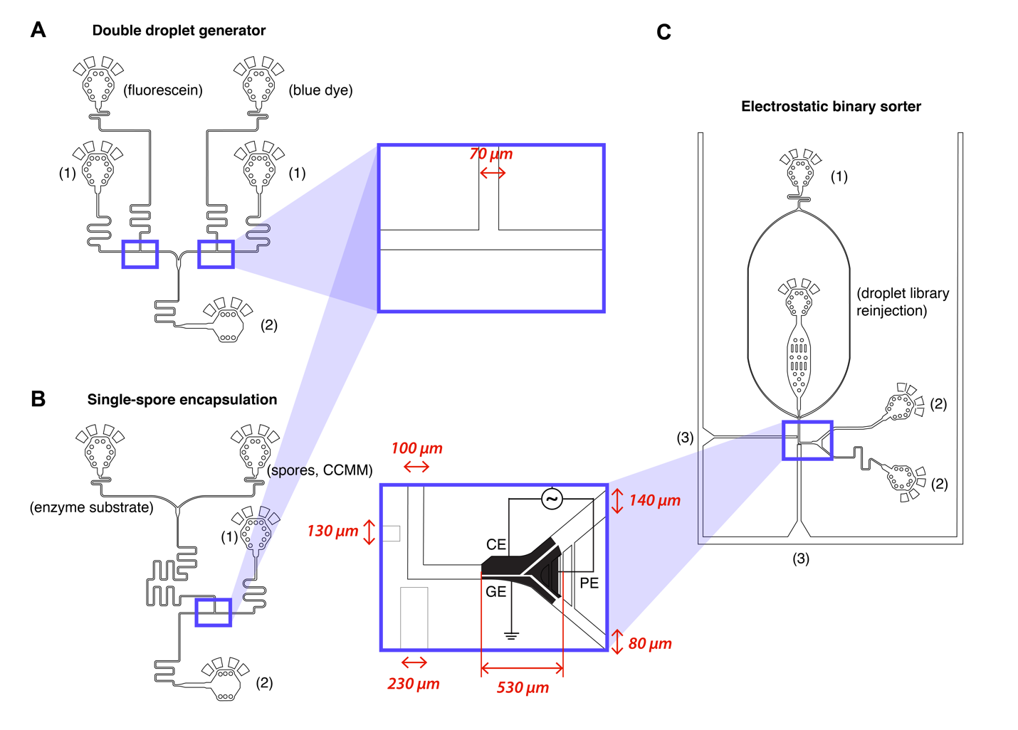
Figure 1 - Microfluidic devices for (A) optimizing sorting parameters and (B and C) fungal enzyme screening. Two T-junction droplet generators (left) were designed with 70 x 70 (w x h) µm channel dimensions. (A) A first droplet generator was used for creating a mixed droplet library for sorter characterization. Fluorescein and blue dye droplets were generated with two separately controlled T-junction droplet generators that produced droplets of the same size (oil/aqueous flow ratio identical) at different flow rates. (B) A second droplet generator was used to generate a filamentous fungi droplet library. An enzymatic substrate and a spore solution were injected at same flow rates (~ 100 nL•s⁻¹), and mixed through a serpentine mixer before droplet generation. Droplets were collected from the outlet (labeled as (2)) into a PCR tube. For both devices, the fluorinated oil (HFE 7500 2% fluoro-based surfactant) was injected into the inlet (labeled as (1)). (C) The microfluidic binary sorter was designed with co-planar electrodes under a dielectric (fabrication similar to our previously reported work^{1,2}). The emission fiber channel (3) has a 100 µm height for the excitation fiber and a 170 µm height for the emission fiber. All other dimensions are as indicated on the zoomed-in sorting region. The droplet library was re-injected into the device inlet and droplets were spaced with spacer oil (1). After sorting, droplets were collected from the outlets (2).

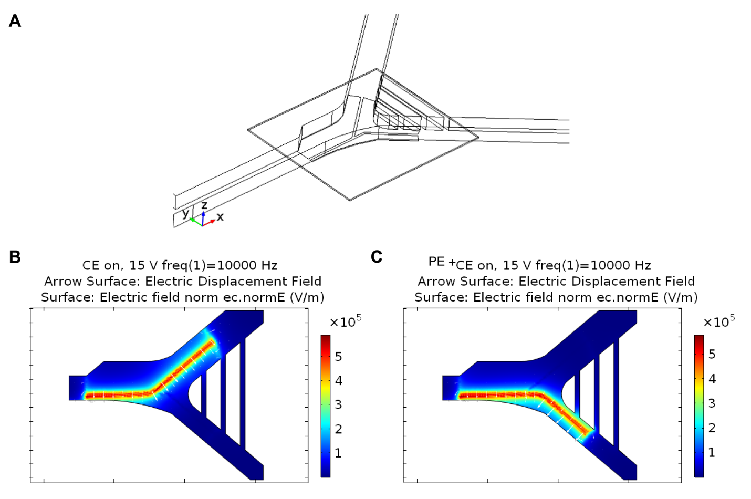
Figure 2 - Simulation of the electric field above the electrodes. (A) Model components include a channel layer with PDMS boundary and HFE 7500 domain, a 7 µm thick dielectric layer and three electrode terminals. (B) Top view of electrostatic displacement field vectors and electric field strength (V/m) at z = 7 µm (SU-8 5 dielectric with HFE7500 oil interface) when the constant electrode (CE) is applied with 15 V_{RMS} at 10 kHz. The electrostatic force vectors are perpendicular to the gap and to the flow. (C) Top view of electrostatic field strength at z = 7 µm when both the CE and the pulsing electrode (PE) are on with 15 V_{RMS} applied.

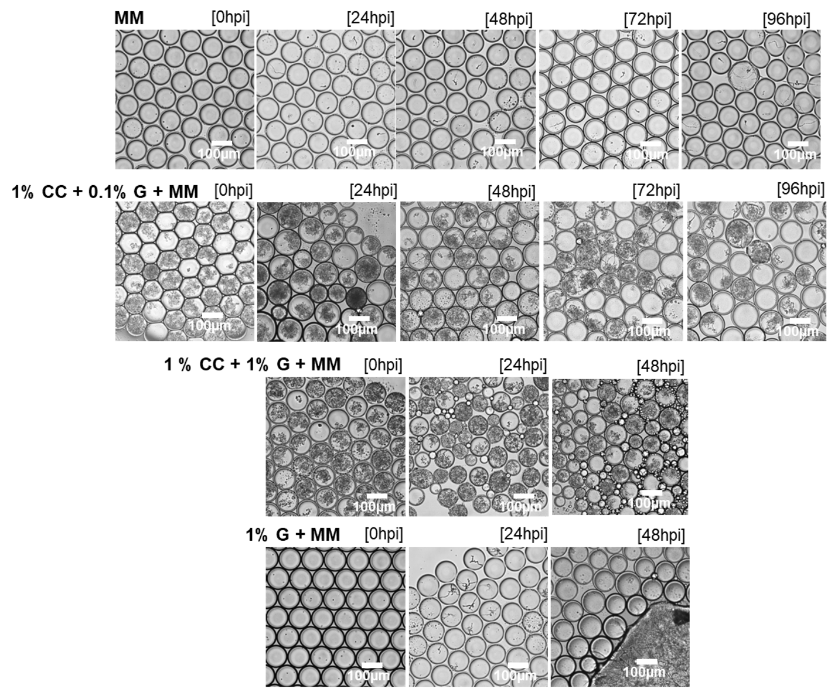
Figure 3 - Incubation of filamentous fungi in the droplets with varying media. Bright field microscopy images of 1 nL droplets incubated in oil with 2 % fluorosurfactant for 96 hours (40x) in a PCR tube. In droplets containing colloidal chitin (CC), the filamentous fungi show hyphal growth around the colloidal chitin and minimizes the hyphae to exit the droplets. After 48 hpi, many of the hyphae in 1% G burst the droplet, causing many of the droplets to merge. Droplets containing 0.1% G or minimal media shows low rates of hyphal exiting, enabling droplets being intact for > 4 days.

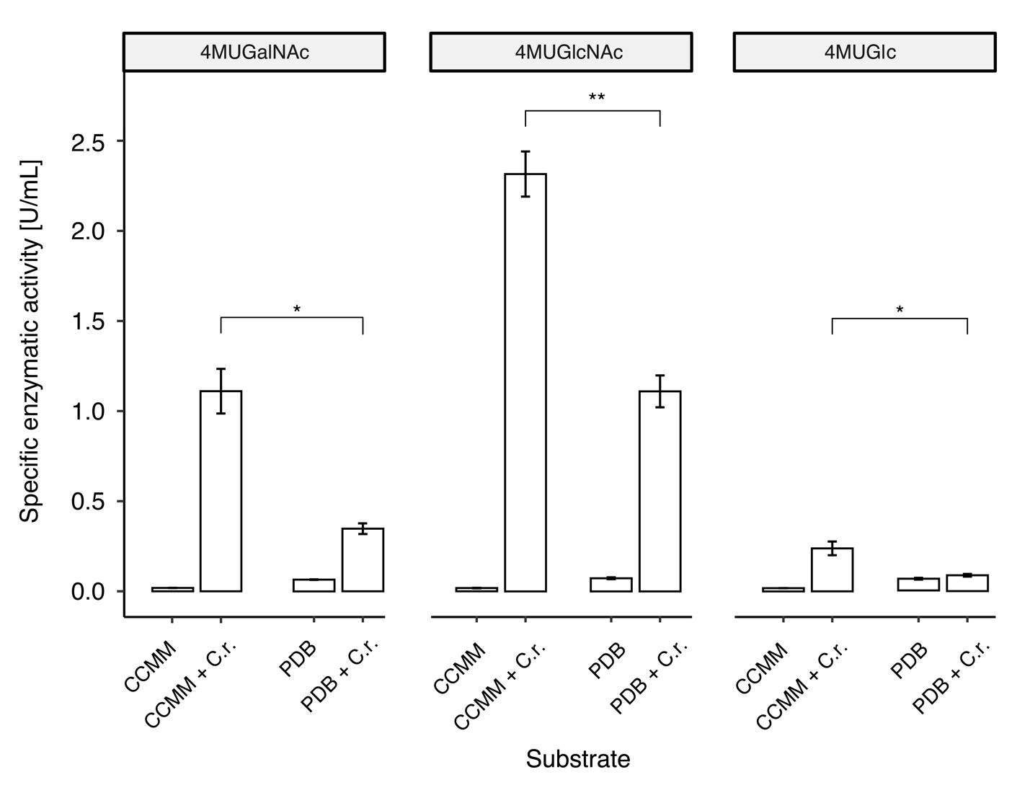
Figure 4 - C.rosea well plate end-point enzymatic assay. The enzymatic activity of cell wall degrading enzymes in C. rosea cultures (27 ºC, 5 days, 200 mL) was compared in different media formulations (colloidal chitin minimal media, CCMM, and potato dextrose broth, PDB). Enzymatic activity is displayed as a specific enzymatic activity (U/mL) using 4-MU-GlcNAc, 4-MU-GalNAc, and 4-MU-Glc as substrates for chitinase, N-acetyl galactosaminidase, and glucanase activity, respectively. A unpaired Welch t-test was performed between the enzymatic activity in C.rosea grown in solid and liquid media (* for P < 0.05, ** for P < 0.01) (30 min, 37 ºC, pH 5.1). Error bars represent one standard deviation, N = 3.

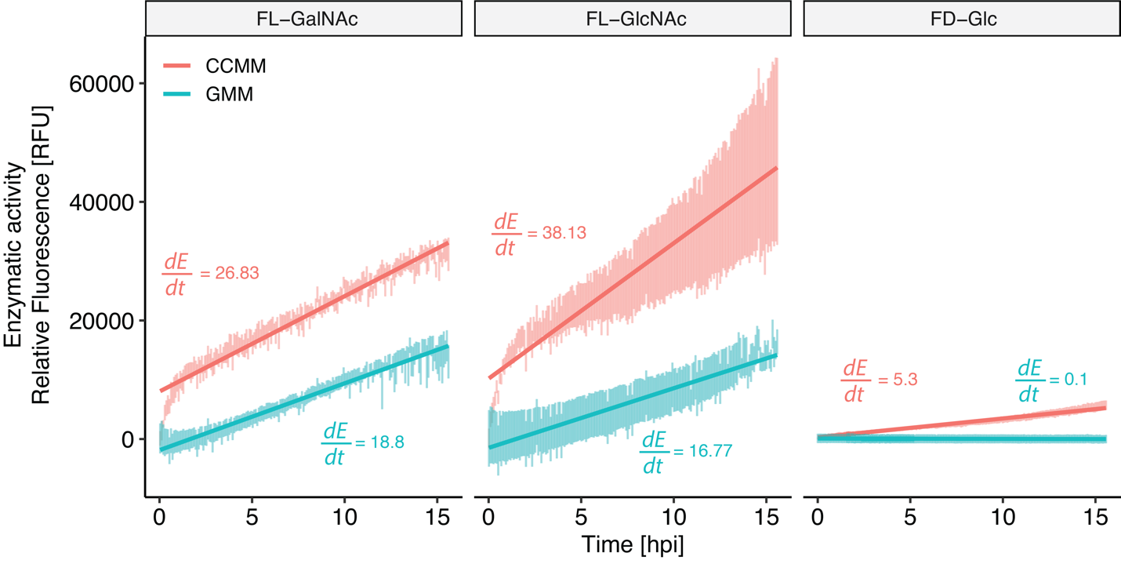

Figure 5 - C.rosea conidia well-plate kinetic assay using fluorescein-based substrates. The enzymatic activity of cell wall degrading enzymes in C. rosea cultures were compared between different media (colloidal chitin minimal media, CCMM (red) and glucose minimal media, GMM (blue)) over 15 h post-incubation. Germination started at 0 h from parent strain spores at concentrations as in droplets (0.5 x10⁷ spores•mL⁻¹) and were incubated (27 ºC, 16 h) with either FL-GlcNAc, FL-GalNAc or FD-Glu as the substrate. At each measured time point, one standard deviation is shown, N = 3. Relative fluorescence is normalized with a control (media and substrate without spores) and slopes dE/dt represent change in enzymatic activity over time. As shown, colloidal chitin media offers a faster increase in fluorescence rate, which will allow for shorter incubation times in droplets.

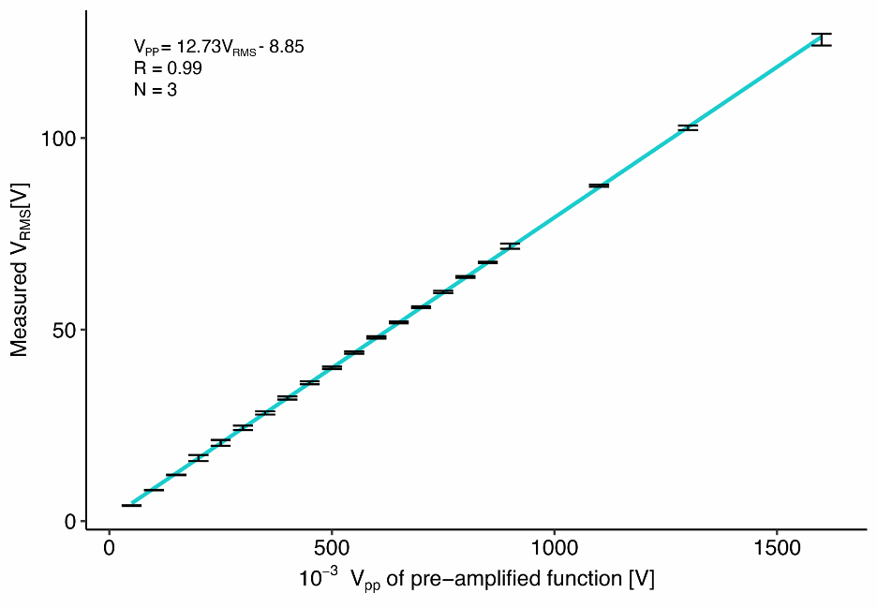

Figure 6 - Amplifier calibration curve. Measured root-mean squared voltage at the electrode, after amplification of a sine wave (10 kHz, variable V_{PP}) using a PZD-700A, Trek Inc. amplifier. The gain at 10 kHz was determined to be 78.85. The resulting linear relationship was used to calculate the true applied potential (V_{RMS}) in experiments and simulations.

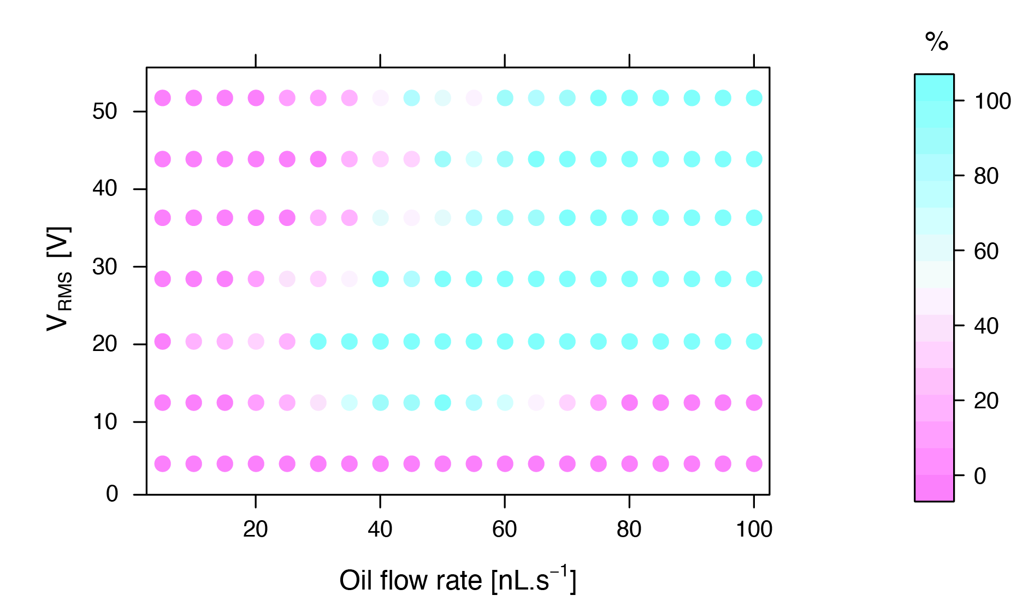
Figure 7 - Efficiency of sorting under different flow rates and applied potential. Dot plot showing the success rate of sorting ([# successfully sorted droplets (T) / # of total droplets sorted (T+F)]* 100 %) in a 7 x 20 factorial design experiment with binary outcome (N = 10). Each dot (or condition), the potential applied to the sorting electrodes were kept at constant frequency (10 kHz), while the spacer oil flowrate was varied. Droplets were generated at 0.5 nL•s⁻¹ (water) and 1 nL•s⁻¹ (oil and surfactant). Blue dots indicate sorting conditions with 100 % sorting success.
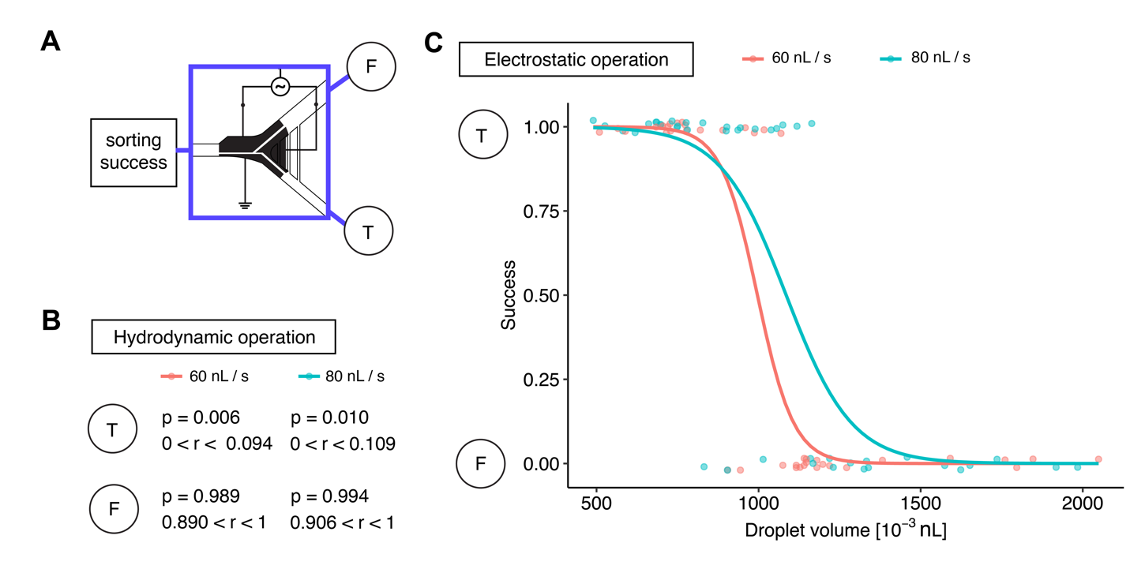
Figure 8 – Sorting success for a polydisperse volume droplet library. (A) Droplets were sorted using a co-planar sorter. A “positive” droplet going into the main channel was considered a sorting failure (F), while a droplet going into the disfavored channel was considered a sorting success (T) (see sorting design schematic). (B) Sorting logic outcome under hydrodynamic operation (free flow without the use of electrodes). The probability of polydisperse volume droplets to enter the disfavored channel was measured under two flow conditions (60 nL•s⁻¹ spacer oil; 80 nL•s⁻¹ spacer oil). At 60 nL•s⁻¹, the probability p of sorting failure due to a false positive (droplet entering the disfavored channel, T, without actuation) is ~0.6%. At 80 nL•s⁻¹, the sorting failure probability is ~1%. (C) Sorting logic outcome under electrostatic sorting. Sorting success of polydisperse volume droplet libraries were measured under two electrostatic sorting regimes (36.3 V_{RMS} actuation, 60 nL•s⁻¹ spacer oil; 44.2 V_{RMS} actuation, 80 nL•s⁻¹ spacer oil). Logic outcome was fitted with a logarithmic binomial regression fit. On average, droplets smaller than ~ 1 nL can be sorted with near-perfect efficiency.

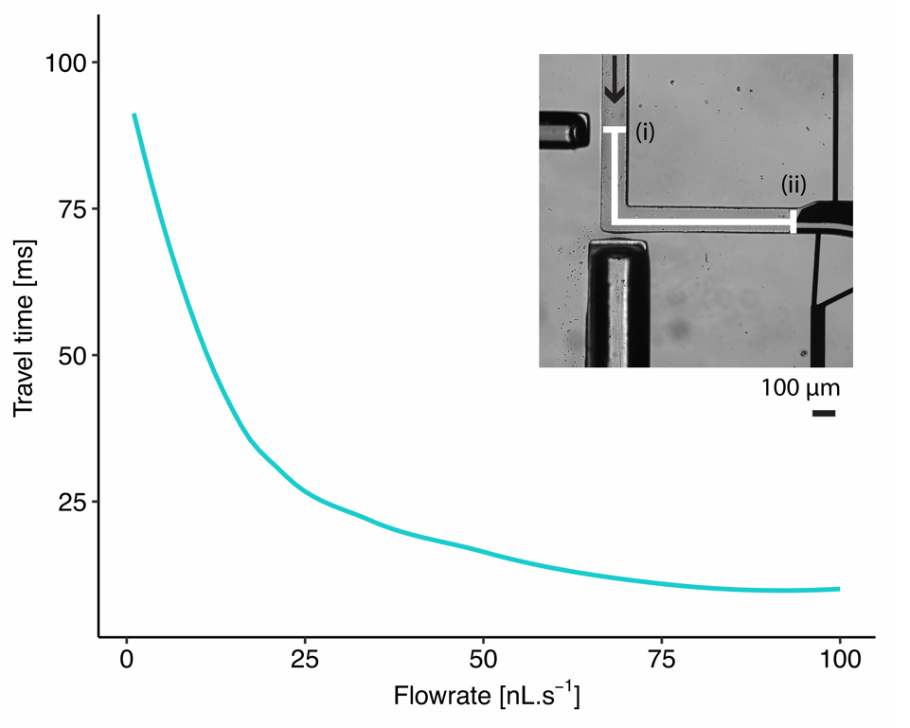
Figure 9 - Droplet sorting timing calibration. Droplet travel time from detection point (i) to sorting point (ii) (~ 1.1 mm) under different oil flow rates. Droplet generation was kept at 3 nL•s⁻¹ aqueous (ddH₂O) and 4 nL•s⁻¹ oil phase (HFE 7500 0.5% fluorosurfactant), while the spacer oil phase varied in flow rate. Time was measured by summing up exposure times of frames in high-speed image series (each frame was captured every ~33 ms).
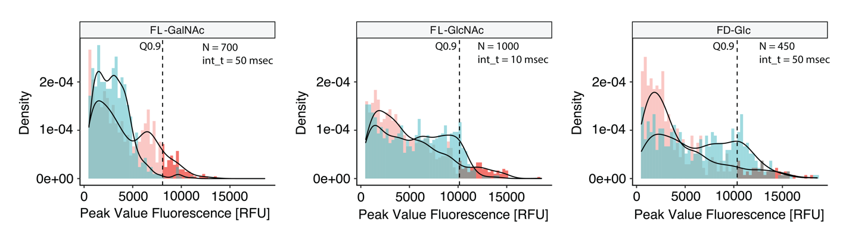
Figure 10 - Sorting histograms of single-spore droplet libraries for each fluorescein substrate. Fluorescence intensity of each droplet in a mutant population (shown as red) and a wild type (shown as blue) population incubated at 27 ºC before microfluidic sorting. Intensity of peaks between the wavelengths 510 nm and 520 nm were used for gating. To sort droplets, the intensity gate was set at the 0.9 quantile of the mutant population fluorescence (shown by the dotted line).

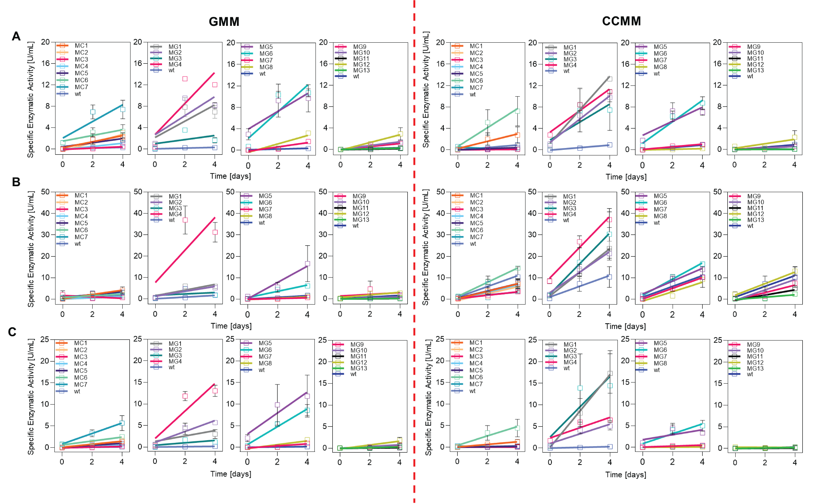
Figure 11 - Production of cell-wall degrading enzymes by strains recovered from the microfluidic screening. Third generation strains were incubated over 4 days in CCMM and GMM liquid culture media and specific enzymatic activity [U/mL] values were obtained through an end-point enzymatic assay (pH 5.1, 30 min) (N = 4 for each point). Plots represent the enzymatic activity of (A) chitinase (B) glucopyranosidase, and (C) N-acetylgalactosaminidase cultured in 1 % colloidal chitin and minimal media (CCMM; left) and 1 % glucose and minimal media (GMM; right). Error bars represent one standard error.

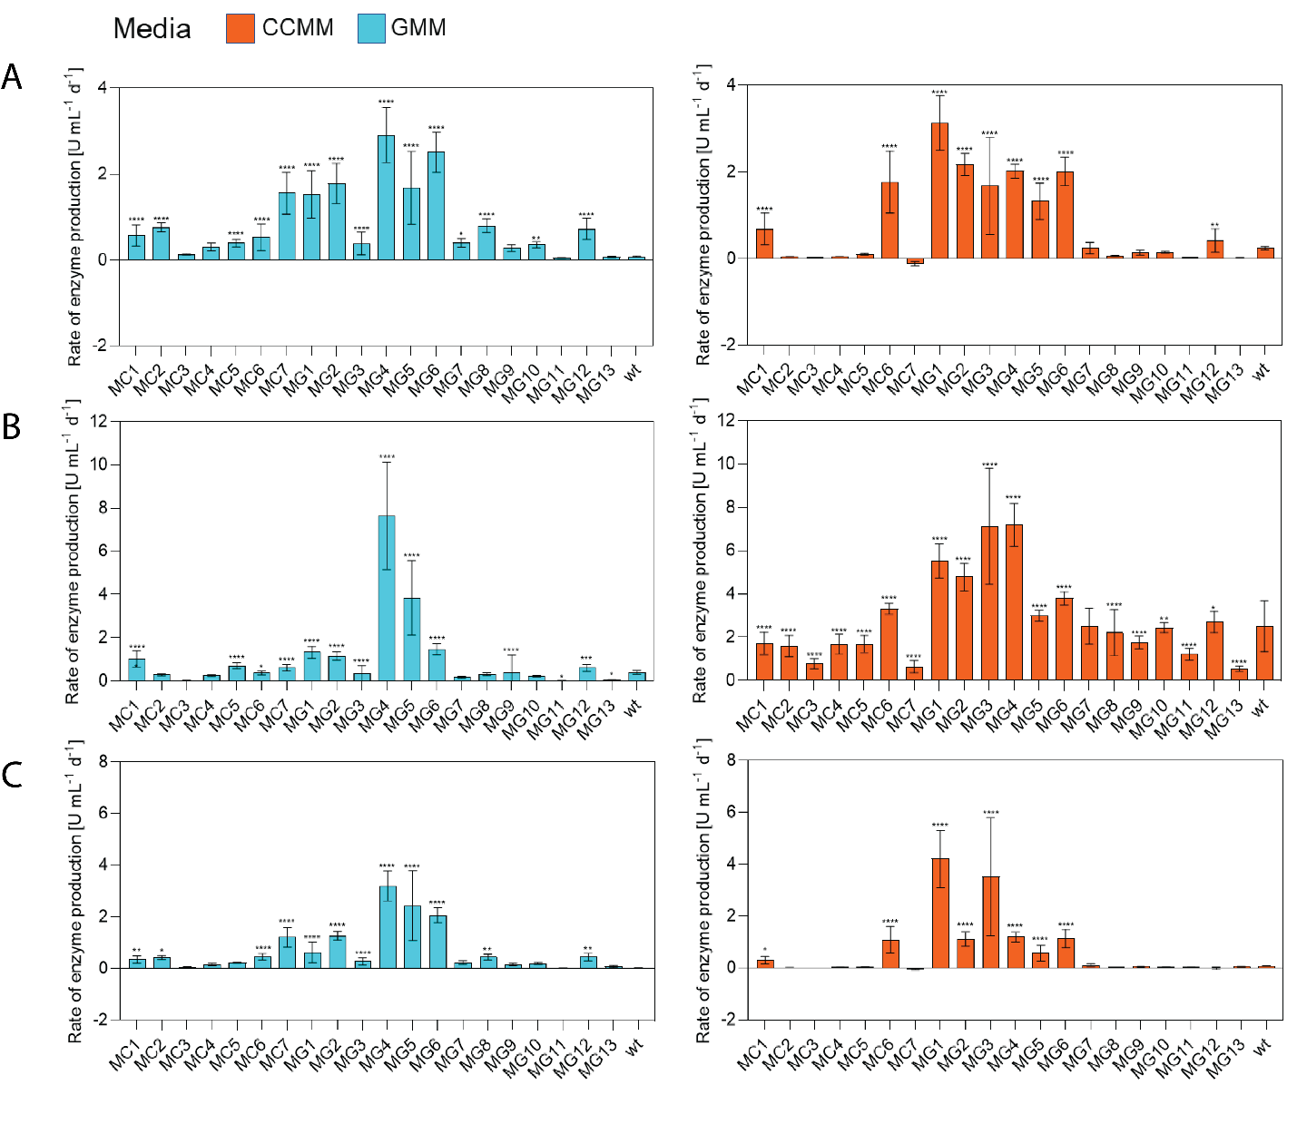

Figure 12 – Rate of enzymatic production of strains recovered from the microfluidic screening after three generations of culture. Plots of the rates for the production (A) chitinase, (B) glucopyranosidase and (C) N-acetylgalactosaminidase were obtained from the slope of simple linear regression, N = 4 (see Figure S11). Error bars representing standard error, one-way ANOVA against WT, P values: 0.1234 (ns), 0.0332 (*), 0.0021 (**), 0.0002 (***), <0.0001 (****).

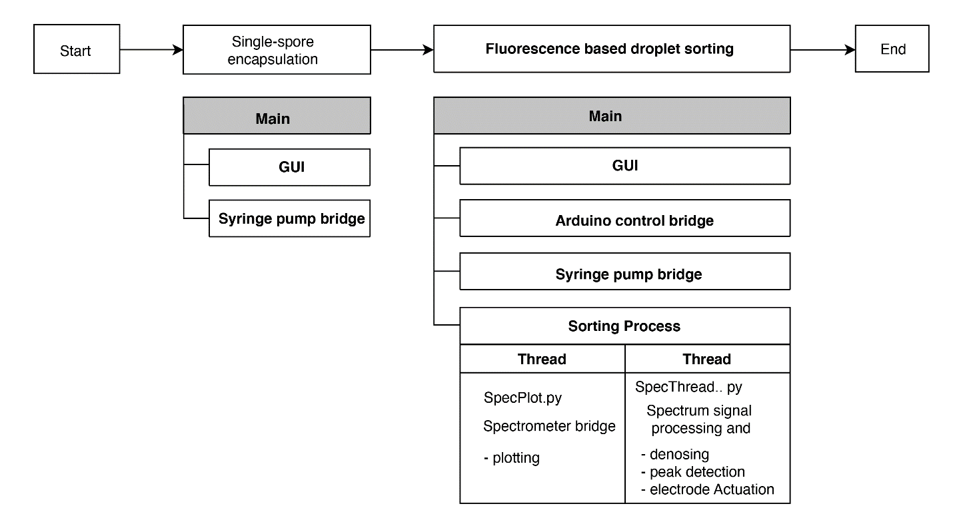
Figure 13 - Software workflow. The Python 3.9 based software is used for two independent experimental steps: single-spore encapsulation and fluorescence-based droplet sorting. For each experiment, a main python process is started to drive hardware and provide a user interface. For single-cell encapsulation, the main process runs a GUI process and a syringe pump bridge process, controlling the pressure driven syringe pumps. For fluorescence-based droplet sorting, the main process executes a GUI process, an Arduino control bridge which operates switches supplying high-voltage to the electrodes, a syringe pump process, and a sorting process. The sorting process contains two sub-processes: a bridge with the spectrometer instrument continuously reading raw intensities and wavelengths, and a signal processing process for signal denoising, background subtraction, peak detection and electrode actuation. Software can be found under GNU GPL v3.0 on https://bitbucket.org/shihmicrolab/fungalmicrofluidics/.

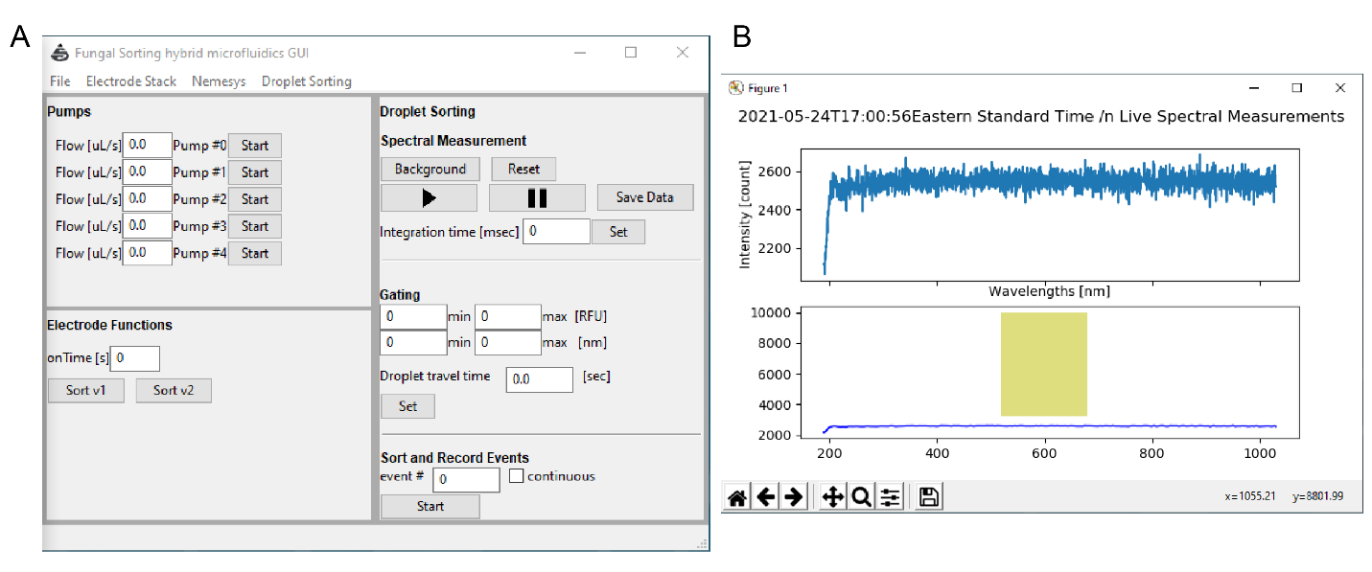

Figure 14 - Graphical user interface for sorting. (A) An image of the control panel graphical user interface for fungal screening. After running a main script, the GUI can be used to control pumps, the electrode switching board, and the spectrometer. The menu ribbon can be used to control the hardware interface and to start and to stop communication with the hardware. Pumps can be controlled in the pump panel by configuring the flow rates of the respective pump and using the start button to start and stop fluid dispensing. Electrodes can be controlled in the electrode panel. Electrode ‘onTime’ can be inputted and buttons are present for users to program custom actuation sequences (e.g., Sort v1 and Sort v2 are pre-made sequences for sorting). The Droplet Sorting panel is used to perform automated droplet sorting. A spectrum viewer can be controlled using the play buttons, data snapshots can be saved, spectrometer integration time can be set, and background fluorescence can be subtracted using the top panel. These operations can be applied to “live” measurements. In the middle panel, the sorting gate (wavelength and intensity) and droplet travel time can be set. The user can start the autonomous sorting by performing a continuous measurement or a selected number of events. The procedure can be paused, and events can be saved in a data file. (B) Spectrum viewer graphical user interface. Raw spectrum (blue) of the emission fiber transferred signal, showing the wavelength and measured intensities (RFU), measured by the spectrometer (top). The spectrum after signal processing (bottom) is also displayed through live plotting. The plotted signal (blue) has the background noise subtracted and is denoised using a third order Butterworth lowpass filter. The user sets the sorting gate and is displayed (shown as a green box).

