Electronic Supporting Information

An electrochemical aptasensor for Δ⁹-tetrahydrocannabinol detection in saliva on a microfluidic platform

László Kékedy-Nagy^{a,b}, James M. Perry^{b,c}, Samuel R. Little^{a,b}, Oriol Y. Llorens^{a,b}
and Steve C.C. Shih^{a,b,c}*

ªDepartment of Electrical and Computer Engineering, Concordia University, 1455 de Maisonneuve Blvd West, Montreal, Quebec, Canada, H3G1M8
^{b}Centre for Applied Synthetic Biology, Concordia University, 7141 Sherbrooke St. West, Montreal, Quebec, Canada, H4B1R6
^{c}Department of Biology, Concordia University, 7141 Sherbrooke St. West, Montreal, Quebec, Canada, H4B1R6

*Corresponding author: Tel.: 514-848-2424 x7579, e-mail: steve.shih@concordia.ca
Table of contents:
Table S1. Participant characteristics. S8
Table S2. The aptamers in order of their copy number in SR-9 against Δ⁹-THC and CBD. S9
Table S3. One-way ANOVA test for Δ⁹-THC detection in the human saliva. S10
Table S4. The mean, standard deviation, and coefficient of variation (CV) for aptamer-MC6OH covered electrodes in the absence or presence of 5 nM Δ⁹-THC S10
Table S5. Comparison with other rapid detection methods for the detection of Δ⁹-THC S11
Fig. S1. The aptamer frequency versus the selection round of the top twenty sequences in terms of their enrichment trajectories. S12
Fig. S2. The specificity of the top twenty sequences by comparing the enrichment in SR-6, SR-7, and SR-9 against Δ⁹-THC versus the frequency of the same sequences against CBD. S13
Fig. S3. The fluorescence quenching of the A-18 aptamer in the presence of Δ⁹-THC and in the presence of CBD by the adherence to graphene oxide. S13
Fig. S4. (A) Representative DPVs recorded with the aptamer-modified electrodes in PBS/ 1 µM MB; and (B) Normalized DPV signals in the absence and the presence of various concentrations of THC (0.1 – 5 µM). S14
Fig. S5. (A) Representative DPVs recorded with the aptamer-modified electrodes in PBS/ 1 µM MB; and (B) Normalized DPV signals in the absence and the presence of various concentrations of THC (1 – 100 nM) for high aptamer surface coverage. S15
Fig. S6. Representative CVs recorded with the aptamer-modified electrodes in PBS/ 1 µM MB, (A) low- and (B) high aptamer surface coverage, with different scan rates. S16
Fig. S7. (A) Representative DPVs recorded with the aptamer-modified electrodes in PBS/ 1 µM MB; and (B) Normalized DPV signals in the absence and the presence of various concentrations of CBN (1 – 100 nM). S17
Fig. S8. (A) Representative DPVs recorded with the aptamer-modified electrodes in PBS/ 1 µM MB; and (B) Normalized DPV signals in the absence and the presence of various concentrations of CBD (1 – 100 nM). S18
Fig. S9. The EIS assessment in Nyquist plot and Bode plot coordinates, with the MC₆OH-modified electrodes in the absence, and presence of 100 nM Δ⁹-THC. S19
Fig. S10. Representative DPVs recorded with the aptamer-modified electrodes in PBS/ 1 µM MB in (A) 50% - and (B) 10% unfiltered saliva in the absence and after the additions of 10, 25, and 50 nM of Δ⁹-THC. S19
Fig. S11. Representative UV-visible absorption spectra recorded with the unfiltered- and filtered saliva. S20
Fig. S12. Representative DPVs recorded in 50% filtered saliva and PBS/1 µM MB with the aptamer/MC₆OH-modified electrodes in the absence and in the presence of 5 nM Δ⁹-THC. S21
Fig. S13. Regeneration study of the aptasensor after stored for 7 days in dry conditions at 4ºC by rinsing with PBS for 1 min. S22

Additional experimental details
Aptamer modification of gold electrodes. Gold disk electrodes were cleaned electrochemically in 0.5 M NaOH between 0.0 and -1.6 V (10 cycles, 0.1 V s⁻¹) and then polished on a micro-cloth pad (Allied, USA) in 1 µm and then 0.1 µM alumina slurries (Allied, USA), respectively, for 2 min each, followed by washing with water and ultra-sonication in 1:1 ethanol-water solution for 10 min. Next, the electrodes were washed with water and electrochemically polished stepwise in 1 M H₂SO₄ (from -0.3 to +1.7 V, 10 cycles, 0.3 V s⁻¹) and 1 M H₂SO₄/10 mM KCl (from 0 to +1.7 V, 10 cycles, 0.3 V s⁻¹) (Ferapontova and Gothelf 2009). Electrochemical surface area of the working electrode was estimated after this step by integration of the gold surface oxide reduction peaks from the last CV scan (2 cycles) in 0.1 M H₂SO₄ by using reference charge density of 390 µC cm⁻¹ (Trasatti and Petrii 1991). The electrodes were thoroughly washed with DI water and kept in neat ethanol before aptamer immobilization.
Screen-printed electrodes (SPE) containing a gold working electrode, a gold counter electrode, and a silver reference electrode on a flexible polyester substrate (Cat. No. IS-W1-2.C1.RS.35, PalmSens B.V. (Houten, the Netherlands) were cleaned in a single step, where they were a ~15 μL aliquot of 0.5 M H₂SO₄ was pipetted onto the electrodes and then cycled between -1.0 to 1.3 V at a scan rate of 0.1 V s⁻¹ for an initial 12 cycles after which the drop was refreshed, and an additional 12 cycles were conducted (Shanmugam et al. 2020). The surface area of the working electrode was estimated by integration of the gold surface oxide reduction peaks from the last CV scan (2 cycles) in 0.5 M H₂SO₄ via a conventional three-electrode cell (Ag/AgCl in 3M KCl as reference and Pt wire as the counter), using a reference charge density of 390 µC cm⁻² (Trasatti and Petrii 1991).
Voltammetric characterization and analysis. Electrochemical experiments were carried out at room temperature inside a Faraday cage. The surface coverage was estimated from the MB signal associated with the binding to the 80-mer aptamer (Г_{aptamer-MB}) was estimated according to the following equation:
Γ_{aptamer-MB} = Q/(nFA) (1)
where Q is the charge (C), obtained by integration of the cathodic peak area, n is the number of electrons involved in MB reduction, F is the Faraday number (C mol⁻¹), and A is the electrochemical surface area of the gold electrode (cm²).
Microfluidic device fabrication and assembly. 3D printed components including PDMS channel molds, and the microfluidics cartridge holder (including a backing plate and mounting washer) were designed using Autodesk Fusion 360. Following design, the geometries were converted to .slt files using Fusion 360 and imported into CURA (.stl to gcode slicing program). Using CURA, the designs were converted to gcode files with a precision of 0.1 mm and an infill of 100%. An Ultimaker 2+ 3D printer was used to print the designs with poly lactic acid. The 3D printed PDMS channel mold was designed to form an 18 mm straight channel with a height and width of 1 mm with a central circular chamber with a diameter of 6 mm and inlet chambers at either end of 3 mm. These dimensions were selected to accommodate the 1 x 35 mm footprint of the SPEs while allowing an overhang of the 6 mm contact pad section to be accessed by the SPE connector. Additionally, two 3 mm disks on either side of the channel were placed to accommodate mounting bolts holes through the PDMS layer. The backing plate and mounting washer were designed to position the SPE beneath the PDMS channel layer and apply pressure via a pair of nuts and bolts to ensure a tight seal.
The PDMS channels were made by combining cross-linking agent with elastomer in a 1:10 weight ratio followed by degassing by centrifugation at 15,000 rpm in 5 mL Eppendorf tubes. Next, the mixture was cured at 65 °C for two hours in a 3D-printed mold. Inlet/outlet and mounting screw holes were made using 1.5- and 3 mm punchers, respectively (Biopsy Punch, Sklar, West Chester, PA). The microfluidic chamber was assembled by layering the back plate, SPE, PDMS channel, and washer and fastened using two hex socket cap screws and nuts (M3 – 12 mm) purchased from McMaster-Carr (Elmhurst, IL). To ensure a tight seal between the PDMS and electrodes, the screws were tightened with the appropriate hex key. See the Supplementary Video S1 for assembly and operation of the device.

Aptamer selection using FRELEX procedure
Step I: Preparation of the immobilization field
First, the immobilization field consisting of a gold chip (7 x 10 x 0.3 mm, Xantec, Germany) coated with thiolated random 8 base pair DNA oligonucleotides was prepared. The 8-mer thiolated random oligonucleotides were dissolved in 50 µL of 10 µM PBS (8.0 mM Na₂PO₄, 1.4 mM KH₂PO₄, 136 mM NaCl, 2.7 mM KCl, pH 7.4) and incubated at room temperature (rt) for 1 hour on the gold chip surface. Next, the chip was air-dried and incubated for 30 min at rt with a 50 µL thiol terminated polyethylene glycol (SH-PEG) while gently shaking, to block the gold chip surface. SH-PEG was subsequently added a second time for 16 hours and removed from the gold chip by washing with de-ionized water and air-dried (Penner 2017).
Step II: Shape selection field
An aliquot of the selection library comprising about 10¹⁵ sequences from a random aptamer library were snap cooled by heating the library to 95ºC for 10 min followed by immediate immersion in ice bath, to ensure removal of any secondary or tertiary structures which could interfere with the proper annealing of the blockers to the selection library. The single stranded (ss) DNA sequences were incubated with the functionalized immobilization field (gold chip covered with the 8-mer oligonucleotides) in 50 µL of selection buffer (20 mM Tris, 120 mM NaCl, 5 mM KCl, pH 7.5) for 30 min at rt, while the remaining solution was removed and discarded. The immobilization-field was washed two-times with 50 µL of 10X TE buffer (10 mM Tris, pH 8.0, 1 mM EDTA), while the remaining bound oligonucleotides were eluted and recovered with two incubations of 15 min each suing 1 mL of Selection Buffer at 95ºC. These elutions were pooled and purified using the GeneJET PCR Purification Kit (Thermo Fisher Scientific, Germany) as described by the manufacturer and eluted with 25 µL of de-ionized water.
Step III: Target selection
The target molecule (Δ⁹-THC) was then added to this purified blocked selection library solution in a total volume to 50 µL 1X Selection Buffer. This solution in added to an immobilization field in five sequential 10 µL drops and incubated for 30 minutes with shaking in an incubator at rt. The remaining solution, i.e., the purified blocked selection library sequences that did not bind to the immobilization field in the presence of the target molecule, was carefully and saved to a fresh tube. The pooled solution was purified as described in the Step I, eluted in 400 µL of de-ionized water and subjected to PCS amplification. The products of each of these PCR reactions were analyzed by gel electrophoresis (10% acrylamide gels, with ethidium bromide staining) to determine the optimum number of cycles required for amplification.

Tables

Table S1. Participant characteristics.
Individual | Gender | Participant code | Age | Sample collection | Tobacco user | Major health issues | Active lifestyle
#1 | Female | F-1 | 32 | 24-05-2022 | Yes | None | No
#2 | Female | F-2 | 28 | 23-05-2022 | No | None | Yes
#3 | Male | M-1 | 30 | 21-05-2022 | Yes | None | No
#4 | Male | M-2 | 38 | 20-03-2022 | No | None | Yes

Table S2. The aptamers in order of their copy number in selection round 9 against Δ⁹-THC and CBD.
Name | Sequence (5’ to 3’) | Copy number | Frequency (Δ⁹-THC) | Frequency (CBD)
A-1 | GCGGGTTTTTTCACTTTTAATTTTCATTCATTTTACCTCT | 9494 | 0.001188 | 0.000388
A-2 | ACAGGCTGCTTTTATTCATTCATACTTTCCTCGATTTACC | 6218 | 0.000778 | 0.000206
A-3 | TGTGTCTTTATTACTCTTCCACTTTTCATCTTTTCTCGTT | 4595 | 0.000575 | 0.000156
A-4 | CTACAGTGCATCTTCCCTCGTCCTTTTACTTACTTCATTC | 4389 | 0.000549 | 0.000217
A-5 | ATCGGCTTCCTTTACATCCTTTTTCATTCATTCTCCGGCA | 4228 | 0.000529 | 0.000173
A-6 | AAGCAGGGGTAAACTTCATTATCTCTTATTTTTATTCATC | 4060 | 0.000508 | 0.000186
A-7 | CGAATCTACAAGGGCTTTCTTCATTCTCGTTCTTCCCCTT | 3761 | 0.000471 | 4.89E-05
A-8 | TCTTCCTTTTTTATCATTTTTACTTACTCATGTATTTTTC | 3746 | 0.000469 | 6.26E-05
A-9 | AGGCTCTCCATTTATCTTCCTCGTTTTAACTACTTCACCC | 3463 | 0.000433 | 0.000121828
A-10 | TGTACTTTCTCGGTTTATTTTAATCTCCACTTTTCCTCGA | 3293 | 0.000412 | 0.000103727
A-11 | GGCCTTCTTGTTCTTCTCGTTCACTTTTCTCTTCAACCCT | 3290 | 0.000412 | 0.000142777
A-12 | AGGCAGACTTTCTCACATTTCATACTTCCTTTTCACTTTC | 2920 | 0.000365 | 0.000100269
A-13 | TCCTCTTACATTCCATTCCTCGTTCCAGTTCATACCATTC | 2872 | 0.000359 | 0.000104032
A-14 | TAGACAGTTCATTTAACTATTCTTTTCACTTTTTCTCGTT | 2814 | 0.000352 | 0.0001622
A-15 | TTATCAATTCTCGTTATTTCCATTCTTTACCAATTCCCCG | 2792 | 0.000349 | 0.000141353
A-16 | GGCGGATTTTCTTGCTTTCAATTTACTCTACTTCTCCTGC | 2655 | 0.000332 | 0.00015081
A-17 | AGGACTTAATCTACATTTCTTTACTTCTCTCATTTCATTT | 2600 | 0.000325 | 0.000123252
A-18 | GTCTTTCGTATTTGCATTCCTCTCTTCTTCATTTCGAGCA | 2574 | 0.000322 | 1.74912E-05
A-19 | TCCACCTTCACACACTTTTATTTTTTGTTTTTACCTCGTT | 2402 | 0.000301 | 0.000125794
A-20 | ACGGGCGGCTATTCATCTTCTCACTTTTCTCACTCTTCAT | 2394 | 0.0003 | 7.99305E-05

Table S3. One-way ANOVA test for Δ⁹-THC detection in the human saliva collected from the four participants in the study.
Participant code | Mean | St. Dev. | F | df | p-Value | F_{crit} | Significance  (p-Value < 0.05)
F-1 | 9.650 | 0.110 | 0.571 | 3, 8 | 0.649 | 4.066 | Not significant
M-1 | 9.363 | 0.419
F-2 | 9.083 | 0.660
M-2 | 9.167 | 0.515

Table S4. The mean, standard deviation, and coefficient of variation (CV) for aptamer-MC6OH covered electrodes in the absence or presence of 5 nM Δ⁹-THC at different time intervals and cycles.
Time | Cycles | I_{p}, _{blank} (µA) |  |  | I_{p, Δ9-THC} (µA)
 |  | Mean. | St. dev. | CV | Mean. | St. dev. | CV
Day-1 | 10 | 0.023 | 0.44*10⁻³ | 1.91 | 0.021 | 0.23*10⁻³ | 1.11
 | 5 | 0.023 | 0.44*10⁻³ | 1.92 | 0.021 | 0.18*10⁻³ | 0.87
 | 3 | 0.023 | 0.21*10⁻³ | 0.89 | 0.021 | 0.94*10⁻⁴ | 0.46
Day-3 | 10 | 0.021 | 0.29*10⁻² | 14.1 | 0.019 | 0.28*10⁻² | 15.3
 | 5 | 0.018 | 0.12*10⁻² | 5.8 | 0.016 | 0.81*10⁻³ | 5.1
 | 3 | 0.019 | 0.11*10⁻² | 5.8 | 0.016 | 0.75*10⁻³ | 4.5
Day-7 | 10 | 0.021 | 0.60*10⁻² | 29.2 | 0.022 | 0.30*10⁻² | 14.4
 | 5 | 0.021 | 0.58*10⁻² | 27.8 | 0.021 | 0.29*10⁻² | 13.7
 | 3 | 0.023 | 0.27*10⁻² | 11.7 | 0.023 | 0.22*10⁻² | 10.0

Table S5. Comparison with other rapid detection methods for the detection of Δ⁹-THC by key characteristics and features.
Method | LOD  (ng mL⁻¹) | Linear range  (ng mL⁻¹) | Medium | Analysis time (min) | Portable | Ref.
EMMA-Senseª | 1.5 | Log c: 0.3-31.4 | saliva | 1 | yes | this work
Carbon-PB/SPE^{b} | 157 | 31.4-126 | saliva | 3 | yes | (Mishra et al. 2020)
GMR^{c} | 5 | 1-200 | saliva | 3 | yes | (Lee et al. 2016)
LED-IF^{d} | 190 | 500-10,000 | saliva | 10 | no | (Mazina et al. 2015)
FAIMS^{e} | 65.1 | 75.2-375 | breath | 2-4 | yes | (Mirzaei et al. 2020)
Carbon-SPE^{f} | 25-50 | Not reported | saliva | 0.5 | no | (Wanklyn et al. 2016)
Au-PET^{g} | 0.1 | 0.1-100 | saliva | 1 | no | (Stevenson et al. 2019)
MBAO^{h} | 50 | Not reported | breath | 3-5 | yes | (Mirzaei et al. 2020)
EPOCH^{i} | 0.2 | Not reported | saliva | 5 | yes | (Yu et al. 2021)
CPE^{j} | 1.3-3.8 | 1-16 | saliva | 5 | no | (Renaud-Young et al. 2019)
cPED-CoPc/SPGE^{k} | 3,270 | 10,000-500,000 | PBS | 20 | no | (Pholsiri et al. 2022)
OECT^{l} | 0.3 | Log c: 0.3-314 | saliva (synthetic) | ~5 | no | (Majak et al. 2021)
ªelectrochemical multiplatform microfluidics aptamer-based sensor; ^{b}carbon-prussian blue screen-printed electrodes; ^{c}giant magnetoresistive platform; ^{d}capillary electrophoresis with a native light-emitting diode induced fluorescence; ^{e}field asymmetric ion mobility spectrometry; ^{f}carbon screen-printed electrodes; ^{g}gold on polyethylene terephthalate biosensor; ^{h}microfluidic-based artificial olfaction technology; ^{i}express probe for on-site cannabis inhalation; ^{j}carbon paper electrode; ^{k}chromatographic paper-based electrochemical device using a cobalt-phthalocyanine modified screen-printed electrode; ^{l}aerosol jet printed organic electrochemical transistor.

Figures

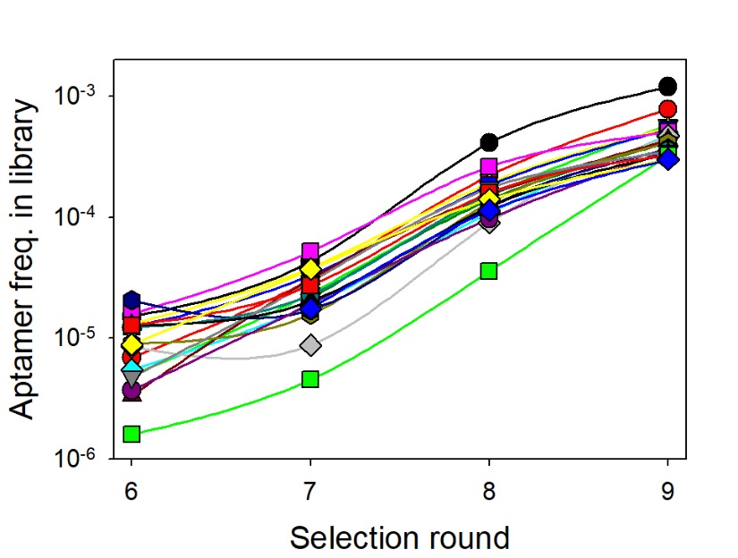
Fig. S1. The aptamer frequency versus the selection round of the top twenty sequences in terms of their enrichment trajectories.

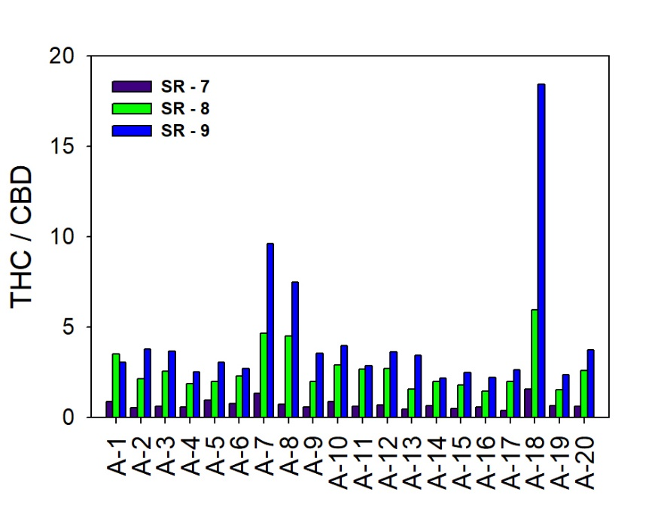
Fig. S2. The specificity of the top twenty sequences by comparing the enrichment in SR-6, SR-7, and SR-9 against Δ⁹-THC versus the frequency of the same sequences against CBD.

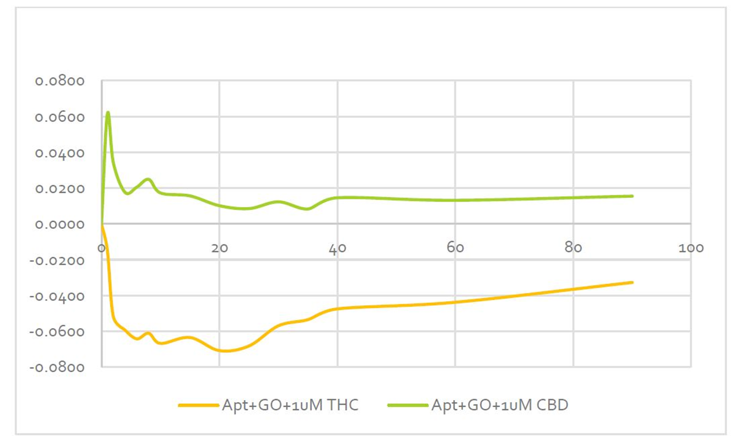
Fig. S3. The fluorescence quenching of the A-18 aptamer in the presence of Δ⁹-THC (yellow line) and in the presence of CBD (green line) by the adherence to graphene oxide.

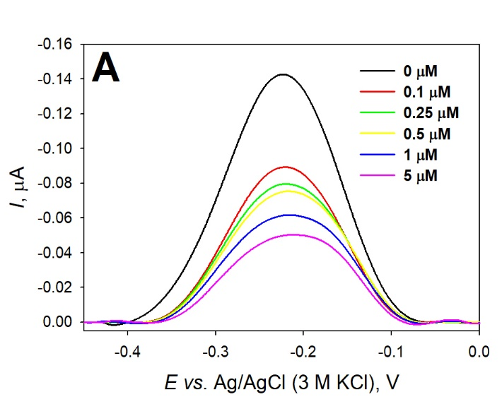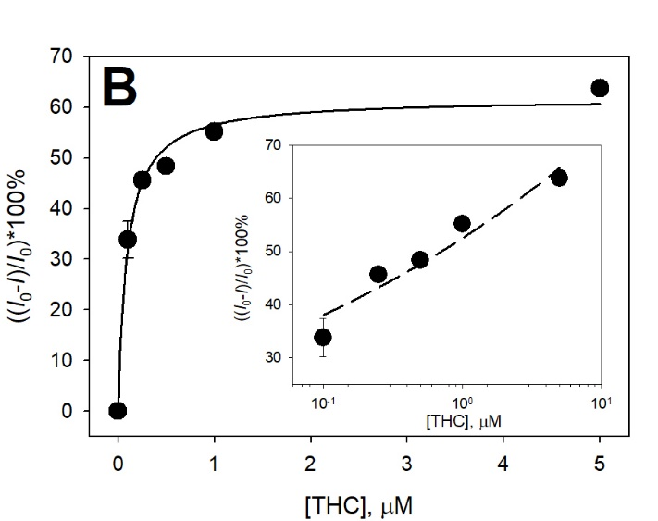
Fig. S4. (A) Representative DPVs recorded in 20 mM PBS/ 150 mM NaCl, pH 7.0 solution containing 1 µM MB with the aptamer/MC₆OH-modified electrodes (black line) before and (colored lines) after the additions of 0.1, 0.25, 0.5, 1, and 5 µM of THC. (B) Dependences of the DPV current signal changes to the background signals in the absence and the presence of various concentrations of THC (0.1 – 5 µM). Inset: the normalized data as of the logarithmic concentration. Surface density: Γ_{aptamer-MB} = 1.8±0.3 pmol cm⁻².

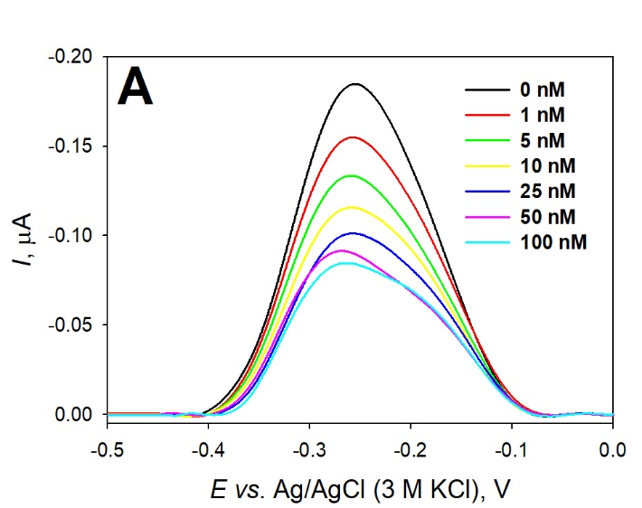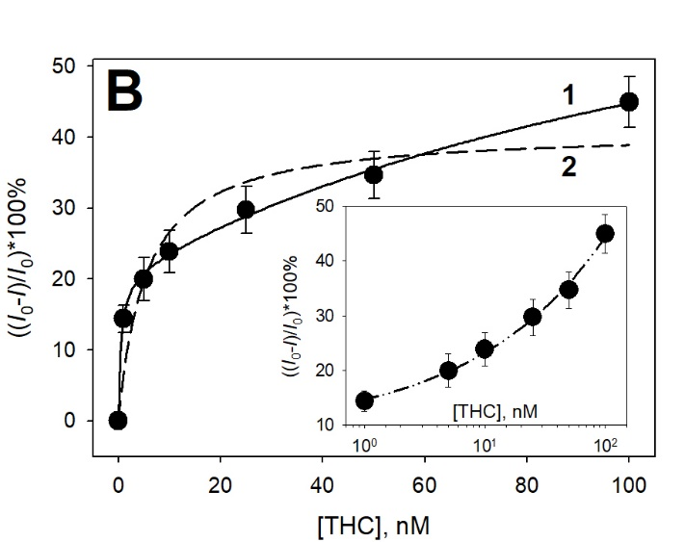
Fig. S5. (A) Representative DPVs recorded in 20 mM PBS/ 150 mM NaCl, pH 7.0 solution containing 1 µM MB with the aptamer/MC₆OH-modified electrodes (black line) before and (colored lines) after the additions of 1, 5, 10, 25, 50, and 100 nM of THC. (B) Dependences of the DPV current signal changes to the background signals in the absence and the presence of various concentrations of THC (1 – 100 nM), where data fitting was performed using (1) the Langmuir adsorption isotherm and (2) the Scatchard model. Inset: the normalized data as of the logarithmic concentration. Surface density: Γ_{aptamer-MB} = 5.3 ± 0.9 pmol cm⁻².

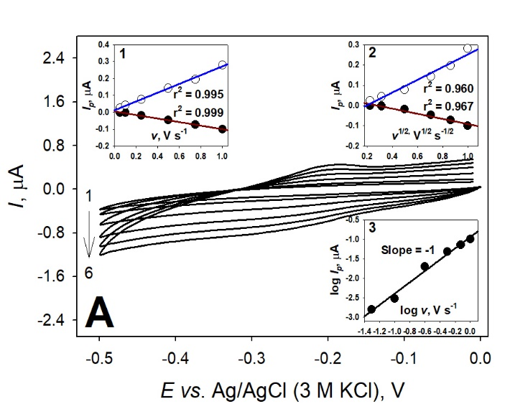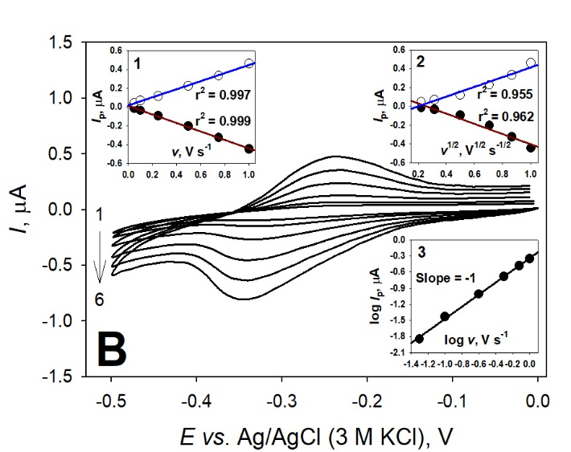
Fig. S6. Representative CVs recorded with the aptamer/MC₆OH-modified electrodes (A) Γ_{aptamer-MB} = 2.1 ± 0.6 pmol cm⁻² and (B) Γ_{aptamer-MB} = 5.3 ± 0.9 pmol cm⁻², in 20 mM PBS/ 150 mM NaCl, pH 7.0 solutions containing 1 µM MB; potential scan rate (from 1 to 6): 0.05, 0.1, 0.25, 0.5, 0.75, and 1 V s⁻¹, respectively. Insets: Anodic and cathodic peak currents plotted vs. (1) the scan rate; (2) the square root of the scan rate; and (3) Logarithmic cathodic peak currents plotted vs. the logarithmic scan rate.

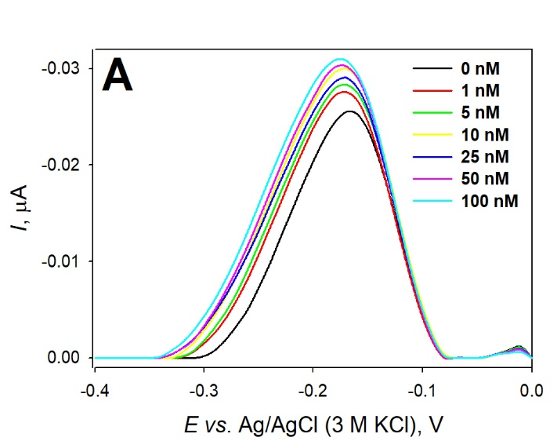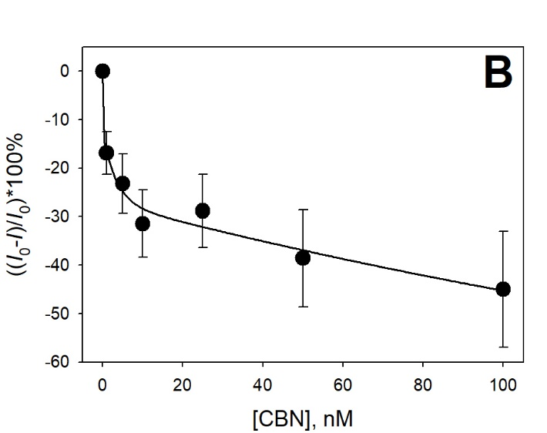
Fig. S7. (A) Representative DPVs recorded in 20 mM PBS/ 150 mM NaCl, pH 7.0 solution containing 1 µM MB with the aptamer/MC₆OH-modified electrodes (black line) before and (colored lines) after the additions of 1, 5, 10, 25, 50, and 100 nM of CBN. (B) Dependences of the DPV current signal changes to the background signals in the absence and the presence of various concentrations of CBN (1 – 100 nM). Inset: the normalized data as of the logarithmic concentration. Surface density: Γ_{aptamer-MB} = 0.9±0.1 pmol cm⁻².

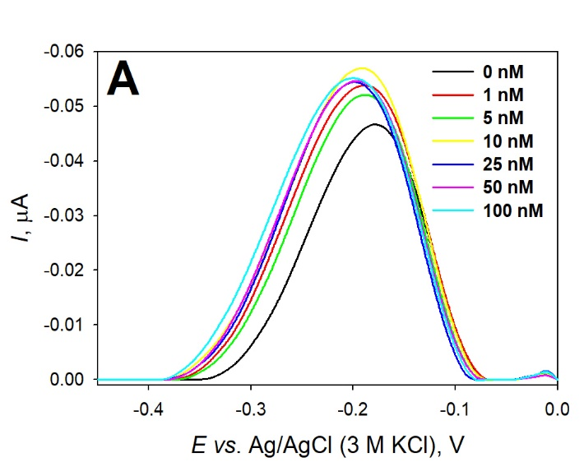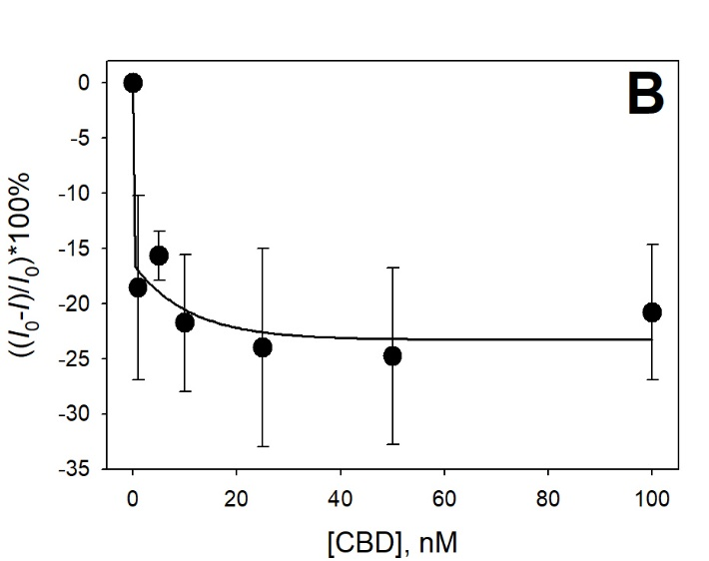
Fig. S8. (A) Representative DPVs recorded in 20 mM PBS/ 150 mM NaCl, pH 7.0 solution containing 1 µM MB with the aptamer/MC₆OH-modified electrodes (black line) before and (colored lines) after the additions of 1, 5, 10, 25, 50, and 100 nM of CBD. (B) Dependences of the DPV current signal changes to the background signals in the absence and the presence of various concentrations of CBD (1 – 100 nM). Inset: the normalized data as of the logarithmic concentration. Surface density: Γ_{aptamer-MB} = 0.7±0.1 pmol cm⁻².

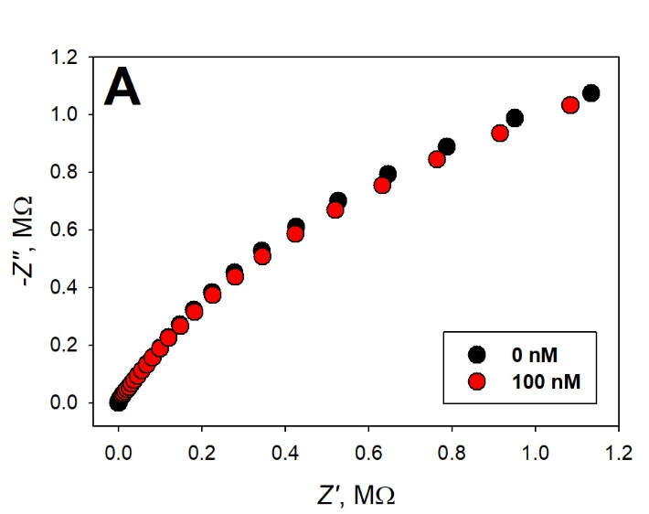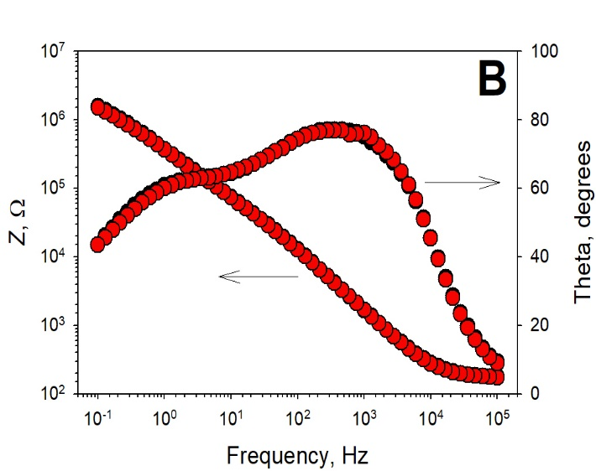
Fig. S9. The EIS assessment in (A) Nyquist plot and (B) Bode plot coordinates, recorded in 20 mM PBS/ 150 mM NaCl, pH 7.0 solution with the MC₆OH-modified electrodes in the absence of Δ⁹-THC (black dots), and in the presence of 100 nM Δ⁹-THC (red dots).

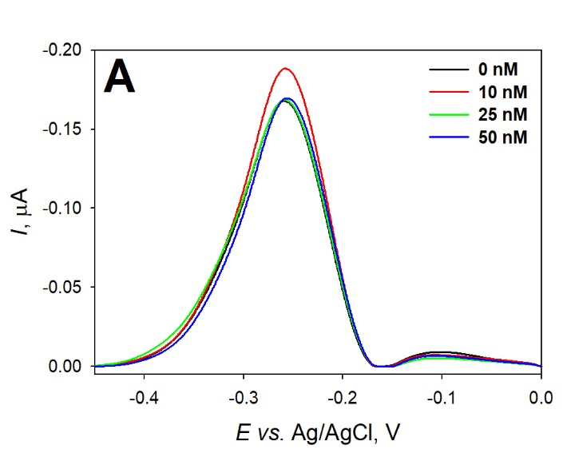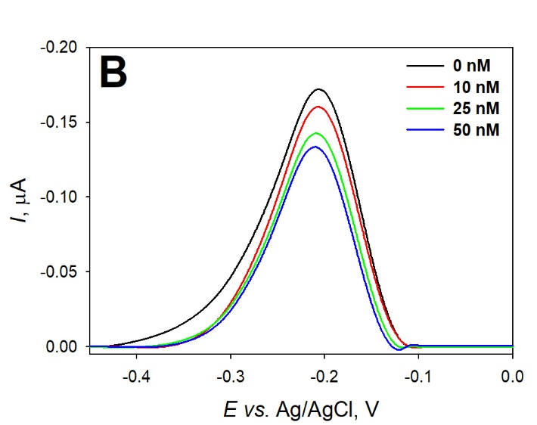
Fig. S10. Representative DPVs recorded in (A) 50% - and (B) 10% raw saliva and 20 mM PBS/ 150 mM NaCl, pH 7.0 solution containing 1 µM MB with the aptamer/MC₆OH-modified electrodes (black line) before and (colored line) after the additions of 10, 25, and 50 nM of Δ⁹-THC.

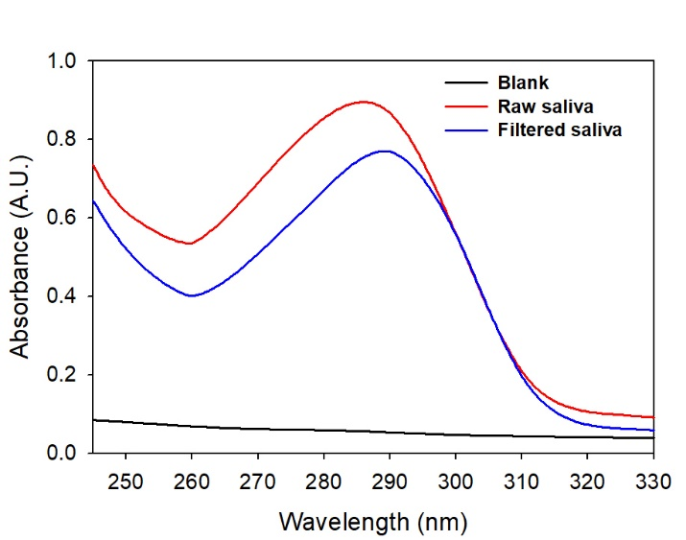
Fig. S11. Representative UV-visible absorption spectra recorded with the raw and filtered saliva, respectively.

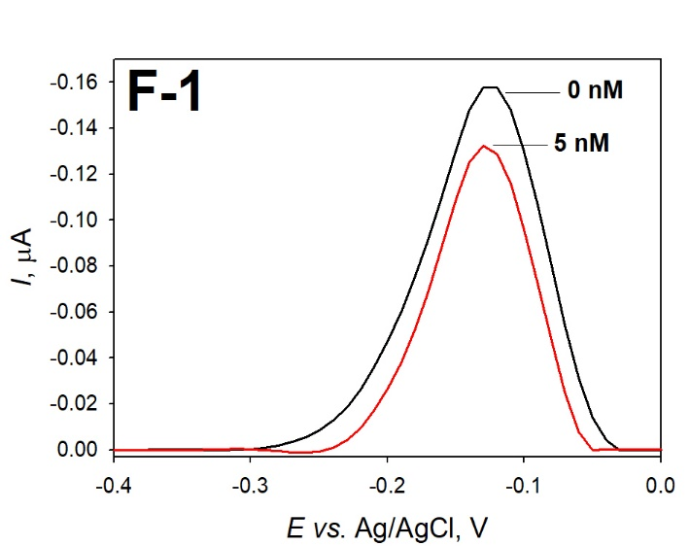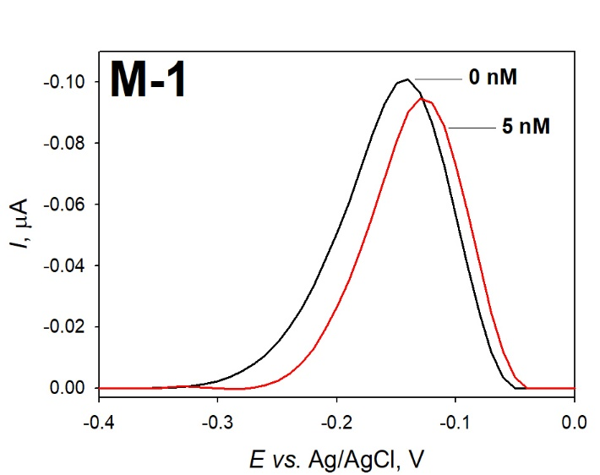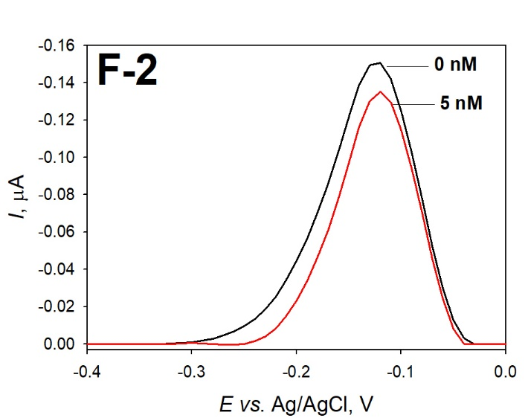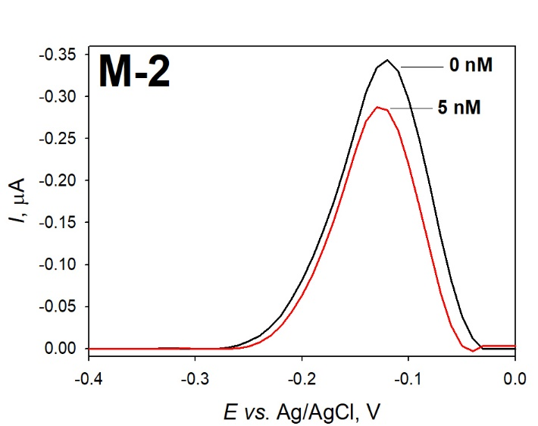
Fig. S12. Representative DPVs recorded in 50% filtered saliva:PBS/1 µM MB (1:1 ratio) with the aptamer/MC₆OH-modified electrodes in the absence (black line) and in the presence of 5 nM Δ⁹-THC (red line).

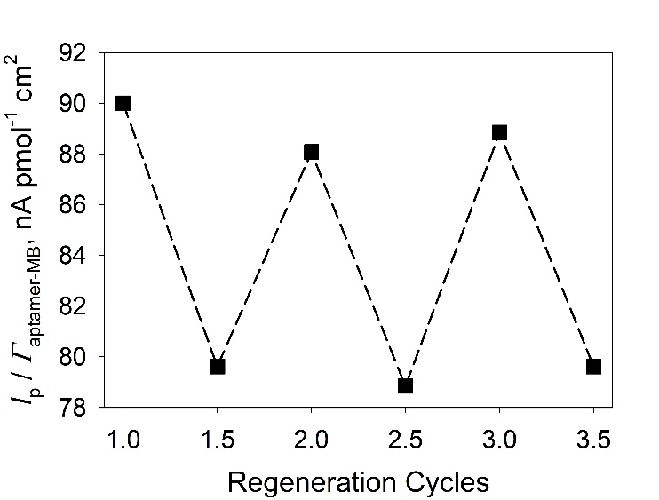
Fig. S13. Regeneration study of the EMMA-Sense after stored for 7 days in dry conditions at 4ºC, based on the I_{p} signal intensities normalized for the Γ_{aptamer-MB} recorded in the absence/presence of of 5 nM Δ⁹-THC by rinsing with PBS for 1 min.

References
Ferapontova, E.E., Gothelf, K.V., 2009. Optimization of the Electrochemical RNA‐Aptamer Based Biosensor for Theophylline by Using a Methylene Blue Redox Label. Electroanalysis 21(11), 1261-1266.

Lee, J.-R., Choi, J., Shultz, T.O., Wang, S.X., 2016. Small molecule detection in saliva facilitates portable tests of marijuana abuse. Anal. Chem. 88(15), 7457-7461.

Majak, D., Fan, J., Kang, S., Gupta, M., 2021. Delta-9-tetrahydrocannabinol (Δ 9-THC) sensing using an aerosol jet printed organic electrochemical transistor (OECT). J. Mater. Chem. B. 9(8), 2107-2117.

Mazina, J., Spiljova, A., Vaher, M., Kaljurand, M., Kulp, M., 2015. A rapid capillary electrophoresis method with LED-induced native fluorescence detection for the analysis of cannabinoids in oral fluid. Anal. Methods 7(18), 7741-7747.

Mirzaei, H., O’Brien, A., Tasnim, N., Ravishankara, A., Tahmooressi, H., Hoorfar, M., 2020. Topical review on monitoring tetrahydrocannabinol in breath. J. Breath Res. 14(3), 034002.

Mishra, R.K., Sempionatto, J.R., Li, Z., Brown, C., Galdino, N.M., Shah, R., Liu, S., Hubble, L.J., Bagot, K., Tapert, S., Wang, J., 2020. Simultaneous detection of salivary Δ9-tetrahydrocannabinol and alcohol using a wearable electrochemical ring sensor. Talanta 211, 120757.

Penner, G., 2017. Method for the selection of aptamers for unbound targets. In: Organization, W.I.P. (Ed.).

Pholsiri, T., Lomae, A., Pungjunun, K., Vimolmangkang, S., Siangproh, W., Chailapakul, O., 2022. A chromatographic paper-based electrochemical device to determine Δ⁹-tetrahydrocannabinol and cannabidiol in cannabis oil. Sens. Actuators B: Chem. 355, 131353.

Renaud-Young, M., Mayall, R.M., Salehi, V., Goledzinowski, M., Comeau, F.J.E., MacCallum, J.L., Birss, V.I., 2019. Development of an ultra-sensitive electrochemical sensor for Δ9-tetrahydrocannabinol (THC) and its metabolites using carbon paper electrodes. Electrochim. Acta 307, 351-359.

Shanmugam, S.T., Trashin, S., De Wael, K., 2020. Gold-sputtered microelectrodes with built-in gold reference and counter electrodes for electrochemical DNA detection. Analyst 145(23), 7646-7653.

Stevenson, H., Bacon, A., Joseph, K.M., Gwandaru, W.R.W., Bhide, A., Sankhala, D., Dhamu, V.N., Prasad, S., 2019. A rapid response electrochemical biosensor for detecting THC in saliva. Sci. Rep. 9(1), 1-11.

Trasatti, S., Petrii, O.A., 1991. Real surface area measurements in electrochemistry. Pure Appl. Chem. 63(5), 711-734.

Wanklyn, C., Burton, D., Enston, E., Bartlett, C.-A., Taylor, S., Raniczkowska, A., Black, M., Murphy, L., 2016. Disposable screen printed sensor for the electrochemical detection of delta-9-tetrahydrocannabinol in undiluted saliva. Chem. Cent. J. 10(1), 1-11.

Yu, H., Lee, H., Cheong, J., Woo, S.W., Oh, J., Oh, H.-K., Lee, J.-H., Zheng, H., Castro, C.M., Yoo, Y.-E., 2021. A rapid assay provides on-site quantification of tetrahydrocannabinol in oral fluid. Sci. Transl. Med. 13(616), eabe2352.

